**L. J INSTITUE OF COMPUTER APPLICATION**



**Fashion Zone**



**Group No : - 17**

**GitHub Link :-** https://github.com/TishaSadariya2904/FZ

**Internal Guide :**

Prof. Jignesh Doshi

Prof. Anuradha Acharya

**Submitted By :**

Miss. Tisha Sadariya (2020004500210052)

Miss. Khushi Makwana (202004500210027)

Mr. Dhruvil Barot (2020004500210007)

**INDEX**

|  |  |  |
| --- | --- | --- |
| SR. No. | Title | Page No. |
| 1 | **Introduction** | **3** |
|  | **1.1 Existing System** | **3** |
|  | **1.2 Need for the New System** | **3** |
|  | **1.3 Objective of the New System** | **3** |
|  | **1.4 Problem Definition** | **4** |
|  | **1.5 Advantages and Limitations of the Proposed System** | **4** |
|  | **1.6 Core Components** | **4** |
|  | **1.7 Assumptions and Constraints** | **5** |
| 2 | **Requirement Determination & Analysis** | **-** |
|  | **2.1 Requirement Determination** | **6** |
|  | **2.2 Targeted Users** | **6** |
|  | **2.3 Project Profile** | **6** |
| 3 | **UML Diagram** | **-** |
|  | **3.1 Use Case Diagram** | **7** |
|  | **3.2 Activity Diagram** | **8** |
|  | **3.3 Sequence Diagram** | **9** |
|  | **3.4 Class Diagram** | **10** |
| 4 | **Data Dictionary** | **11** |
| 5 | **Development** | **-** |
|  | **5.1 Screenshots** | **13** |
| 6 | **Agile Documentation** | **-** |
|  | **6.1 Agile Project Charter** | **38** |
|  | **6.2 Agile Roadmap / Schedule** | **39** |
|  | **6.3 Agile Project Plan** | **40** |
|  | **6.4 Agile User Story** | **41** |
|  | **6.5 Agile Release plan** | **42** |
|  | **6.6 Agile Sprint Backlog** | **43** |
|  | **6.7 Agile Test Plan** | **45** |
|  | **6.8 Agile Earned-value & Burn chart** | **46** |
| 7 | **Future Work** | **47** |
| 8 | **Bibliography** | **47** |

1. **Introduction**

The business-to-consumer aspect of product commerce (e-commerce) is the most visible business use of the world wide web. The primary goal of an e-commerce site is to sell goods online.

E-Commerce is fast gaining ground as an accepted and used business paradigm. More and more business houses are implementing web sites providing functionality for performing commercial transaction over the web. It is reasonable to say that the process of shopping on the web is becoming commonplace.

An online store is a virtual store on the Internet where customers can browse the catalog and select products of interest. The selected items may be collected in a shopping cart. At checkout time, the items in the shopping cart will be presented as an order. At that time, more information will be needed to complete the transaction. Usually, the customer will be asked to fill or select a billing address, a shipping address, a shipping option, and payment information such as credit card number or cash on delivery. An e-mail notification is sent to the customer as soon as the order is placed.

* 1. **Existing System**
* In today’s fast-changing business environment, it’s extremely important to be able to respond to client needs in the most effective and timely manner. If your customers wish to see your business online and have instant access to your products or services.
* Most of the people, nowadays just a sweeping some items into a phone and they are like the items than they can order it.
* Most of the people, nowadays just sweeping some items into a phone. If they like something, they order it.
* Easy to search, which is a customer need.
  1. **Need for the New System**
* Analysis will be very easy in proposed system as it is automated.
* Easy service search, which is a homeowner’s need.
* This system can offer several benefits for homeowners and service providers, making it a valuable addition to the home services industry.
  1. **Objective of the new System**
* The objective of ecommerce website is to be able to sell goods directly to a user. B2B type occurs when a transaction of products or services takes place between two businesses.
* The objective of this project is to develop a general-purpose e-commerce store where product like clothes can be bought from the comfort of home through the Internet. However, for implementation purposes, this paper will deal with an online shopping for clothes.
* The objective of this project is to develop a general-purpose e-commerce store where any kind of product can be bought from the comfort of home through the Internet. However, for implementation purposes, this paper will deal with an online shopping for baby product.
* Nowadays Everyone is very busy in their own life, so that save their time.
  1. **Problem Definition**
* Existing system are a failing in providing quick operation
* Cost is high as well.
* Processing very lengthy and time consuming.
* More time consume for before generation.
  1. **Advantages and Limitations of the Proposed System**
* **Advantages**
  + Saves Time
  + Fresh and Quality Product Assurance
  + 24/7 Ordering
  + Home Delivery
  + Discount coupons available online (like vouchers)
  + Detail information of Product
  + User can replace the order
* **Limitations / Constraint**
  + 14/7 customer service
  + User Can’t using UPI
  + User Can’t cancel order
  1. **Core Component**

1. User Management
   * Registrations
   * Login
   * Homepage
   * Product page
   * Crud product
   * Product Categories
   * Search functionalities
   * Product Description
   * Product Availabilities
   * Wishlist
   * Shopping cart
   * Bill
   * Captcha
   * Feedback
   * About us
   * Contact us
   * Logout
   * Crud customer
   * Customer reviews and feedback
   * Dashboard
   * CSV/Excel
   * Bulk upload
   * Bulk Download
2. Transactional Management
   * Cart (Add/Remove)
   * Payment Gateway
   * Order management
3. Master Management
   * Dashboard Overview
   * Review Management
   * Order Management
   * Category Management
   * Products Management
   * User Management
   * Feedback Management
   * Bill Management
4. Report
   * Download PDF, CSV, Excel (admin)
   1. **Assumptions and Constraints**
      * **Assumptions**
        + The customer have access to reliable internet connections for the smooth functioning of the system.
        + The system assumes that there is a sufficient demand for home services in the market to sustain the business model.
        + The system assumes that the quality of service providers available on the platform is high, which ensures customer satisfaction.
      * **Constraints**
        + The system's geographical coverage is limited to the regions.
        + The system may face challenges in ensuring consistent quality control.
        + The system depends on the availability of service providers to provide services.
5. **Requirement Determination & Analysis**
   1. **Requirement Determination**
      * Some of the analysis of our system
        + **Security**
          - Only authorized people can make changes in database.
        + **Main ability**
          - If anything occur in the system it can be easily maintained.
        + **Reusability**
          - This project is reusable by any institute.
   2. **Targeted Users**
      * Admin
      * Seller
      * User
      * Visitors
   3. **Project Profile**

|  |  |
| --- | --- |
| Project Title | Fashion Zone |
| Institute | L J Institute of Computer Application |
| Front End | 1. HTML5 2. CSS3 3. Bootstrap 4. JavaScript 5. jQuery 6. Django Version 4.1.6 |
| Back End | MySQL Version 8.0 |
| Language | Python Version 3.10.5 |

1. **UML Diagram**
   1. **Use Case Diagram**

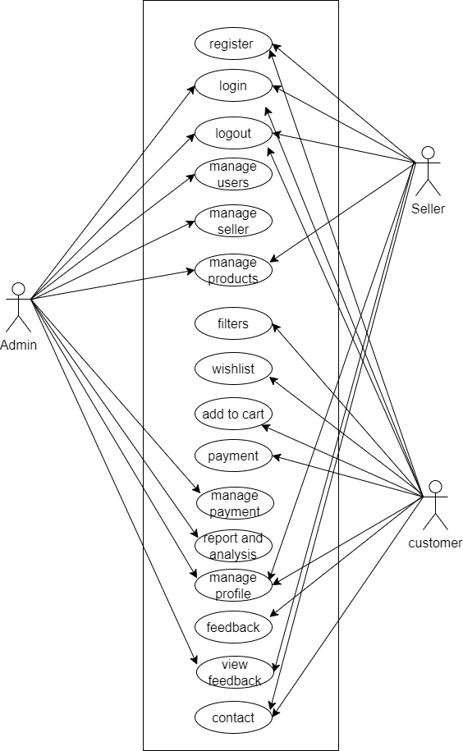

* 1. **Activity Diagram**

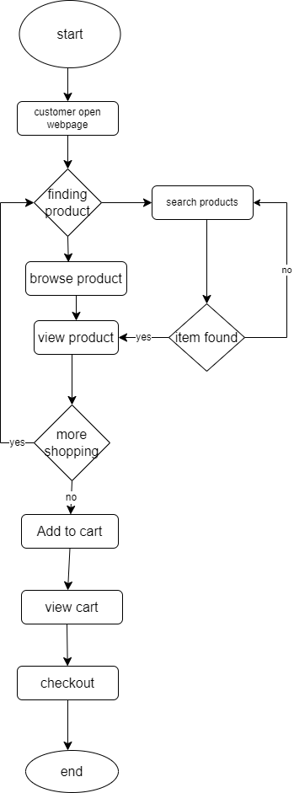

* 1. **Sequence Diagram**

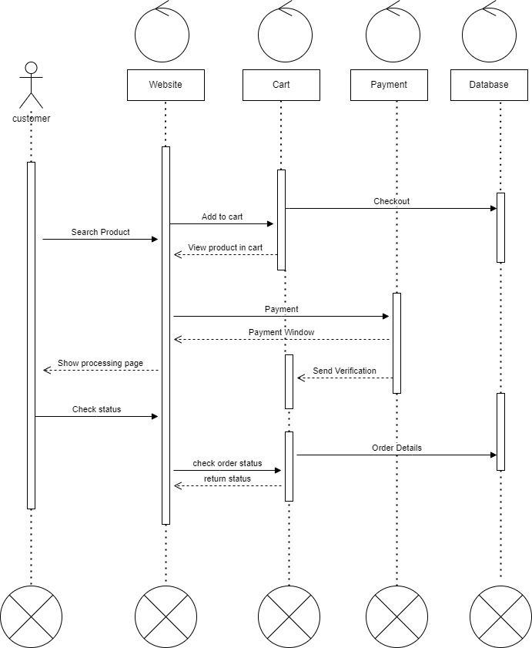

* 1. **Class Diagram**

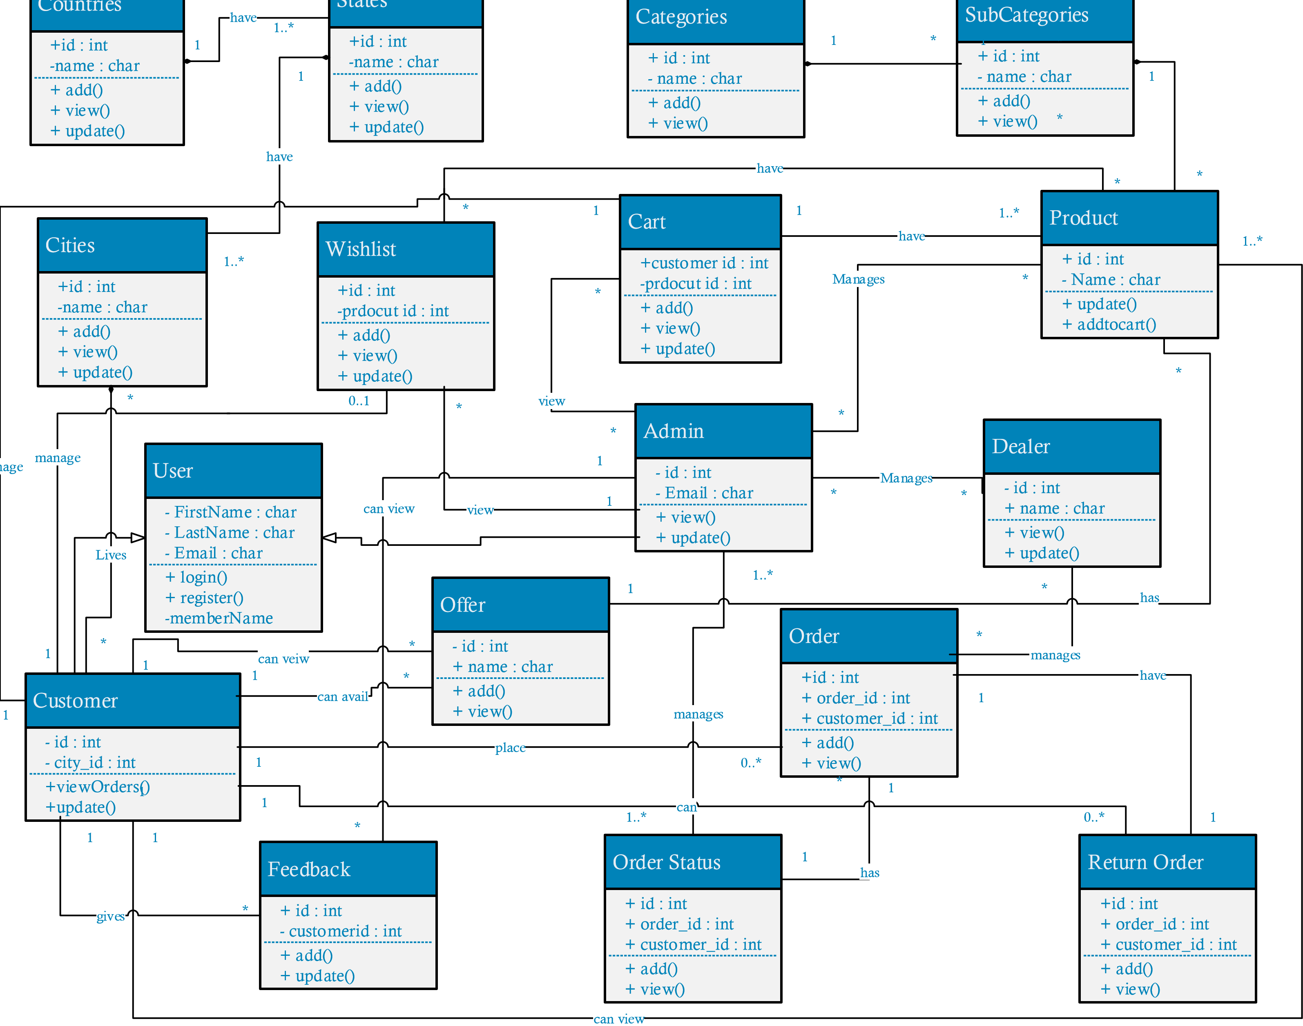

1. **Data Dictionary**
   1. **Customer Table**

|  |  |  |  |  |
| --- | --- | --- | --- | --- |
| Sr No | Field | Data Type | Constraint | Description |
| 1 | Cust_id | Int(4) | Primary key | User ID |
| 2 | first_name | Varchar(15) | Not Null | User First Name |
| 3 | last_name | Varchar(15) | Not Null | User Last Name |
| 4 | email_id | Varchar(40) | Not Null | User E-mail id |
| 5 | Password | Varchar(15) | Not Null | User Password |
| 6 | Image | Image | Not Null | User Image |

* 1. **Seller Table**

|  |  |  |  |  |
| --- | --- | --- | --- | --- |
| Sr No | Field | Data Type | Constraint | Description |
| 1 | Seller_id | Int(4) | Primary key | Seller id |
| 2 | First_name | Varchar(15) | Not Null | Seller first Name |
| 3 | Last_name | Varchar(15) | Not Null | Seller last Name |
| 4 | Email_id | Varchar(40) | Not Null | Seller E-mail id |
| 5 | Password | Varchar(15) | Not Null | Seller Password |
| 6 | Image | Image | Not Null | Seller Image |
| 7 | Seller_ States | Varchar(10) | Not Null | Seller States |

* 1. **Admin Table**

|  |  |  |  |  |
| --- | --- | --- | --- | --- |
| Sr No | Field | Data Type | Constraint | Description |
| 1 | Id | Int(4) | Primary key | Admin ID |
| 2 | Email | Varchar(40) | Not Null | Admin E-mail id |
| 3 | Password | Varchar(15) | Not Null | Admin Password |

* 1. **Category Table**

|  |  |  |  |  |
| --- | --- | --- | --- | --- |
| Sr No | Field | Data Type | Constraint | Description |
| 1 | Category_id | Int(4) | Primary key | Category ID |
| 2 | Category_name | Varchar(15) | Not Null | Category Name |
| 3 | Creation date | Date | Not Null | Category creating date |

* 1. **Product Table**

|  |  |  |  |  |
| --- | --- | --- | --- | --- |
| Sr No | Field | Data Type | Constraint | Description |
| 1 | Product_id | Int(4) | Primary key | Product Id |
| 2 | Category_id | Int(4) | Foreign Key | Category ID |
| 3 | Product_Name | Varchar(50) | Not Null | Product Name |
| 4 | Image | Image | Not Null | Image of item |
| 5 | Description | Varchar 2(100) | Not Null | Product description |
| 6 | Creation date | Date | Not Null | Product creating date |

* 1. **Contact Us Table**

|  |  |  |  |  |
| --- | --- | --- | --- | --- |
| Sr No | Field | Data Type | Constraint | Description |
| 1 | Contact_id | Int(4) | Primary Key | Contact Us |
| 2 | First_name | Varchar(50) | Not Null | First Name |
| 3 | Last_name | Varchar(50) | Not Null | Last Name |
| 4 | Email | Varchar(40) | Not Null | Email ID |
| 5 | Mobile | Int(11) | Not Null | Phone Number |
| 6 | Message | Varchar(500) | Not Null | Message |

* 1. **Feedback Table**

|  |  |  |  |  |
| --- | --- | --- | --- | --- |
| Sr No | Field | Data Type | Constraint | Description |
| 1 | Feedback_id | Int(4) | Primary Key | Feedback |
| 2 | Cust_id | Int(4) | Foreign Key | User ID |
| 3 | Status | Int(2) | Not Null | Read / Unread |
| 4 | Message | Varchar(500) | Not Null | Question List |

* 1. **Cart Table**

|  |  |  |  |  |
| --- | --- | --- | --- | --- |
| Sr No | Field | Data Type | Constraint | Description |
| 1 | Id | Int(4) | Primary key | Place Order Id |
| 2 | Cust _id | Int(4) | Foreign Key | User id |
| 3 | Product_Name | Varchar(50) | Foreign Key | Product Name |
| 4 | Image | Image | Not Null | Image of item |
| 5 | Quantity | Int(200) | Not Null | Quantity of Product |

* 1. **Billing Table**

|  |  |  |  |  |
| --- | --- | --- | --- | --- |
| Sr No | Field | Data Type | Constraint | Description |
| 1 | ID | Int(4) | Primary key | Billing ID |
| 2 | Cust_id | Int(4) | Primary key | User ID |
| 3 | first_name | Varchar(15) | Not Null | User First Name |
| 4 | Email | Varchar(40) | Not Null | User E-Mail |
| 5 | Contact | Number(10) | Not Null | User Number |
| 6 | Product_id | Int(4) | Foreign key | Product Id |
| 7 | Product_Name | Varchar(50) | Foreign Key | Product Name |
| 8 | Price | Number(20) | Not Null | Price |
| 9 | Quantity | Int(200) | Not Null | Quantity |
| 10 | Date of Generation | Date | Not Null | Date of join |

1. **Development**
   1. **Screen Sort**
      * **Visitors**

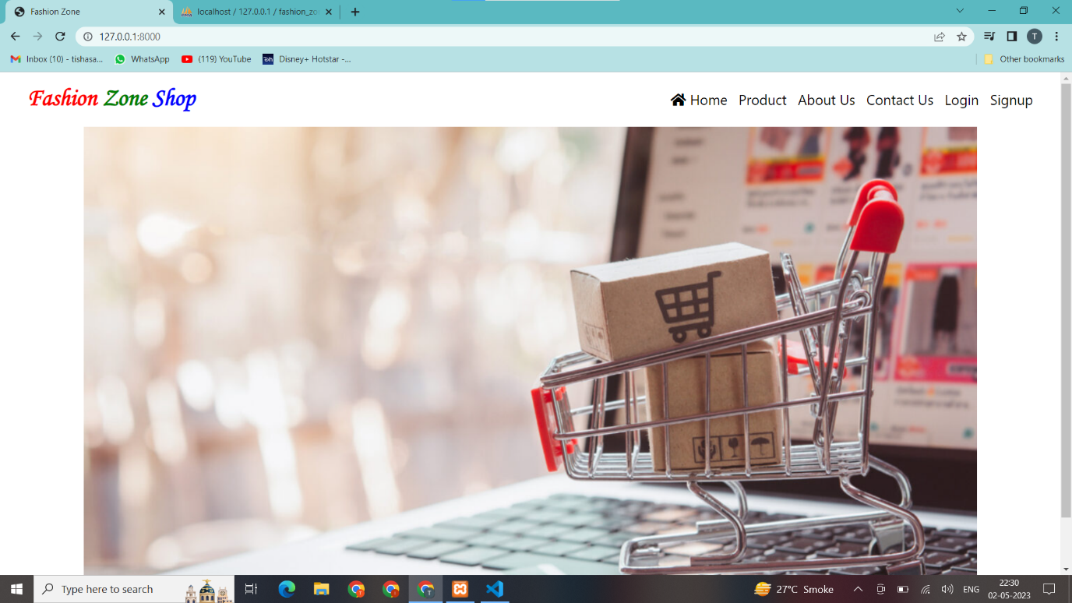

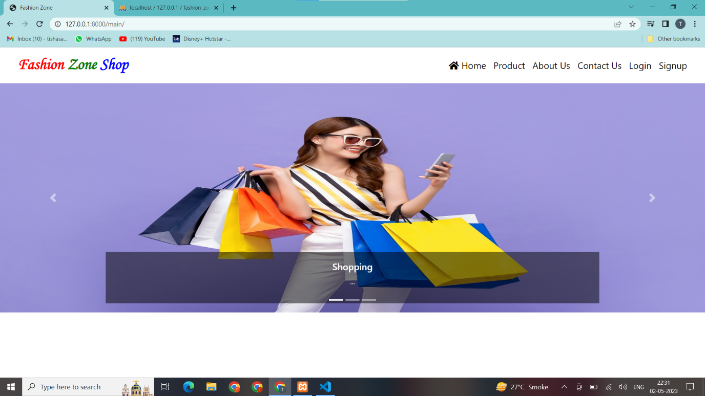

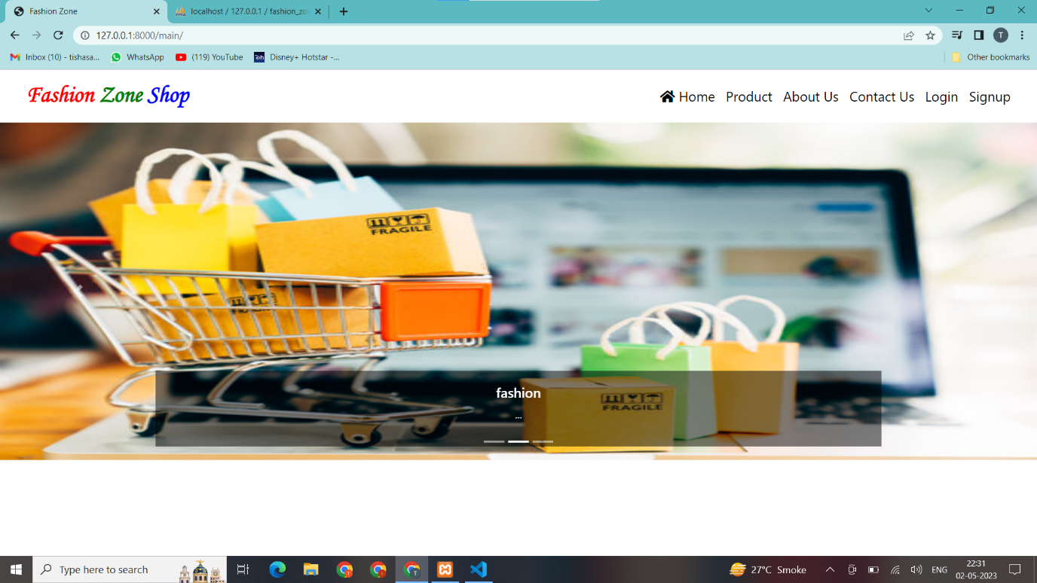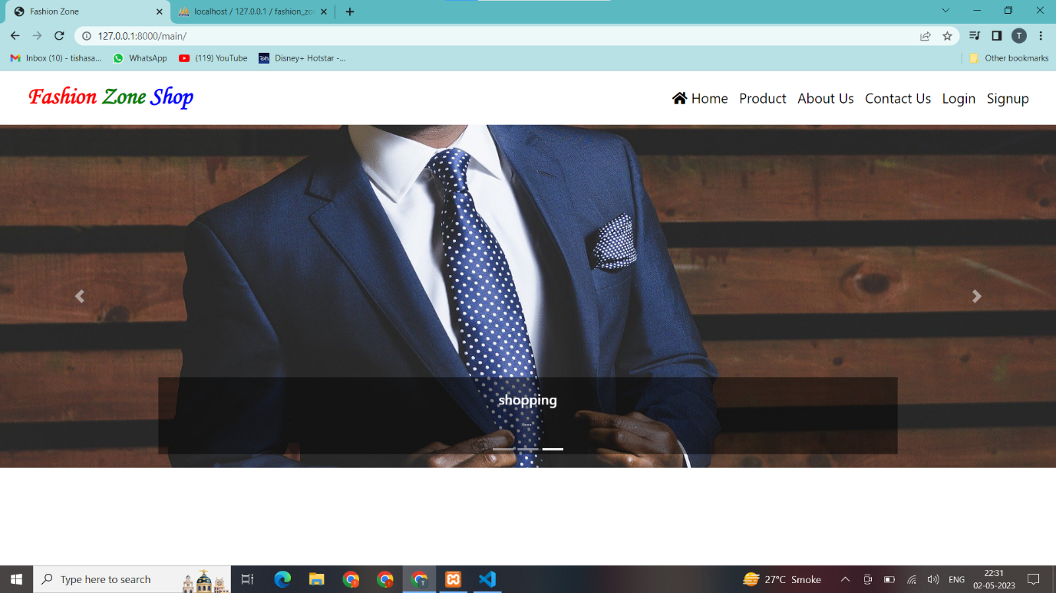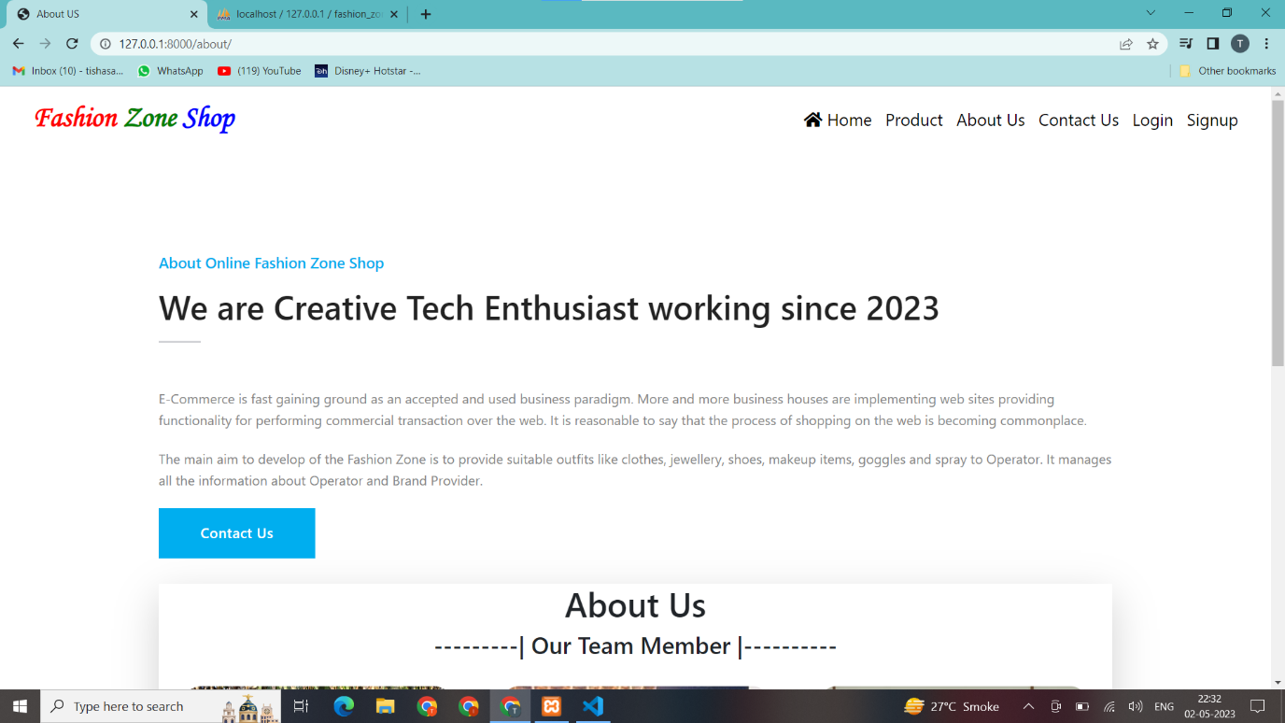

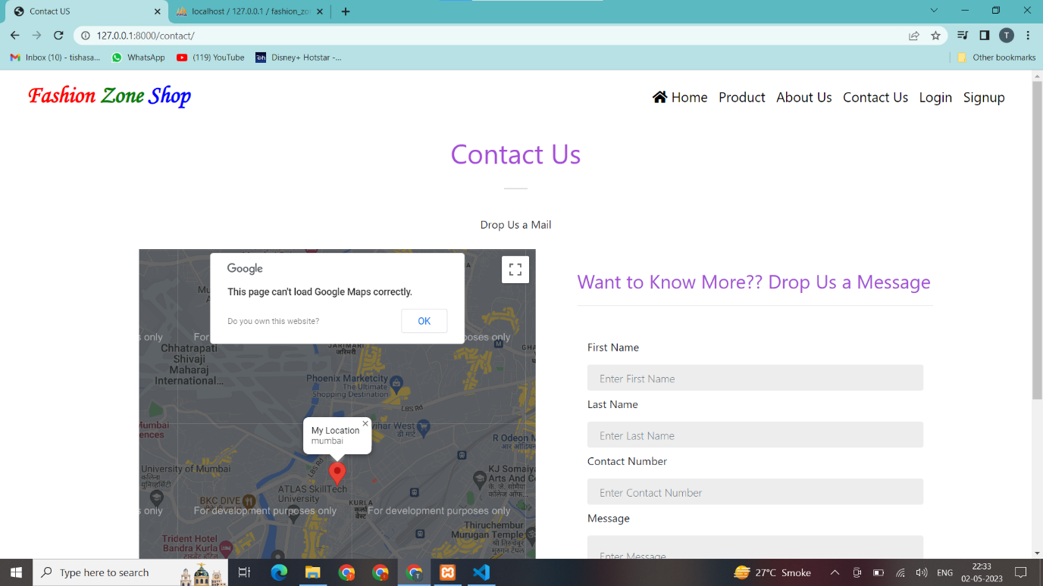

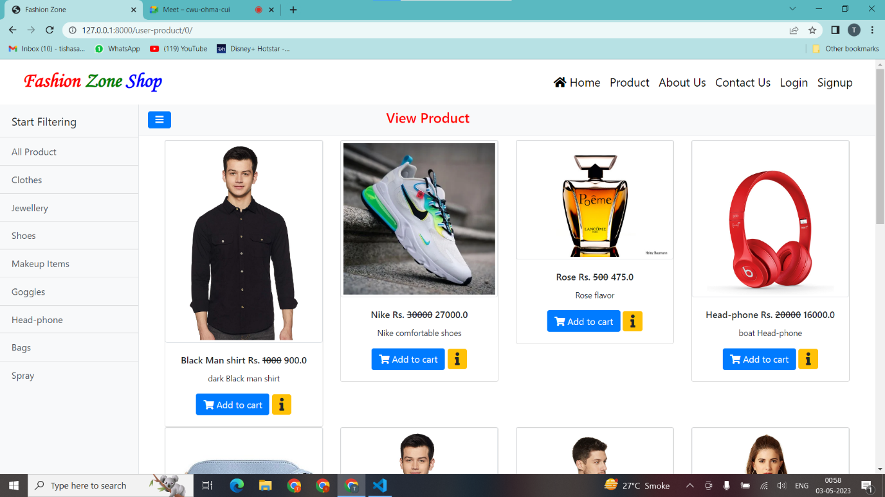

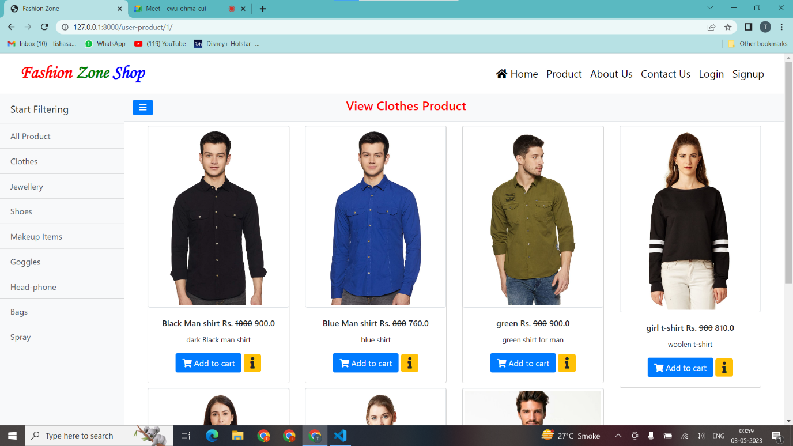

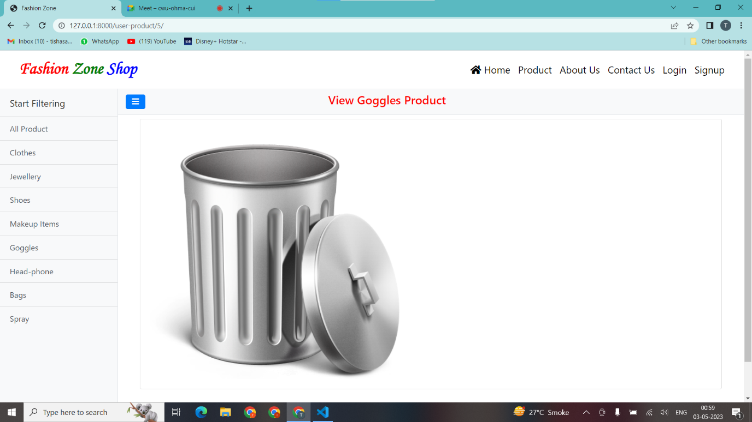

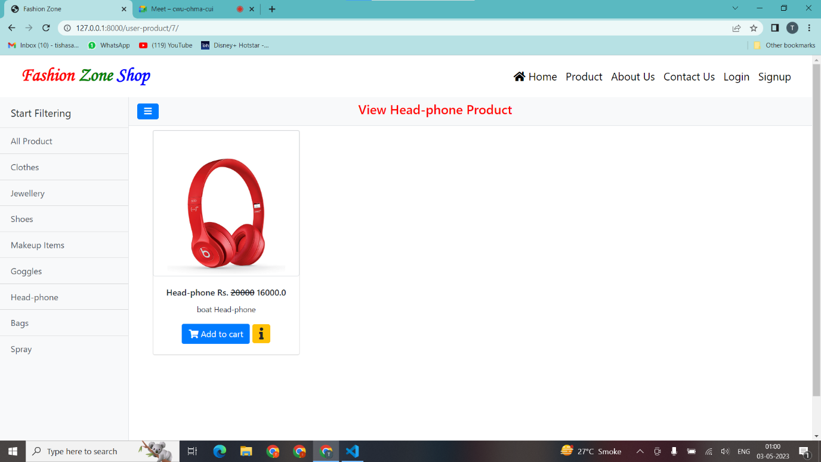

* + - **User**

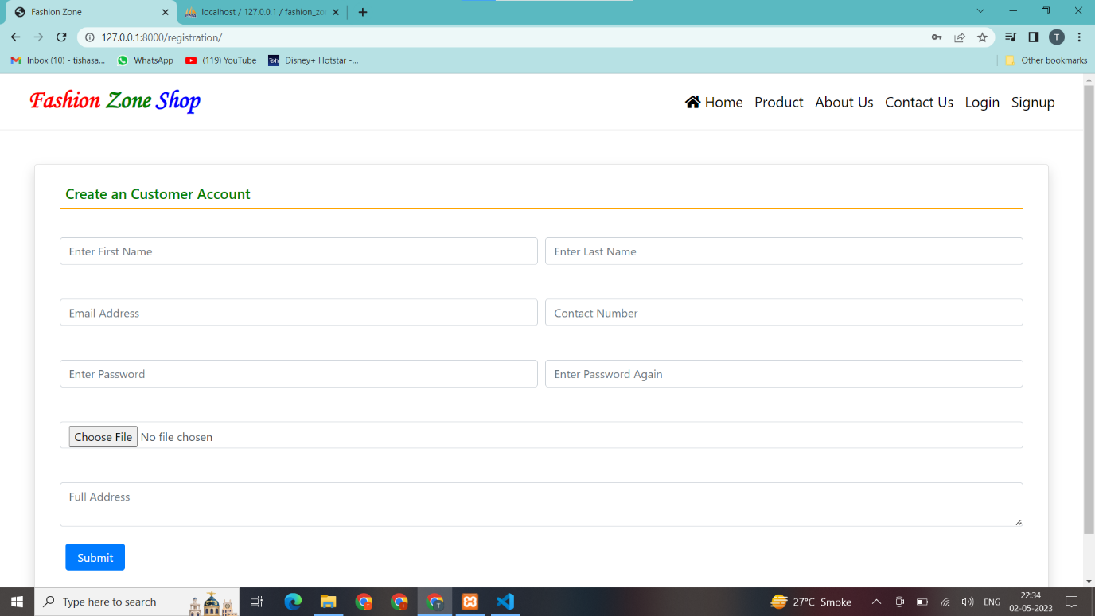

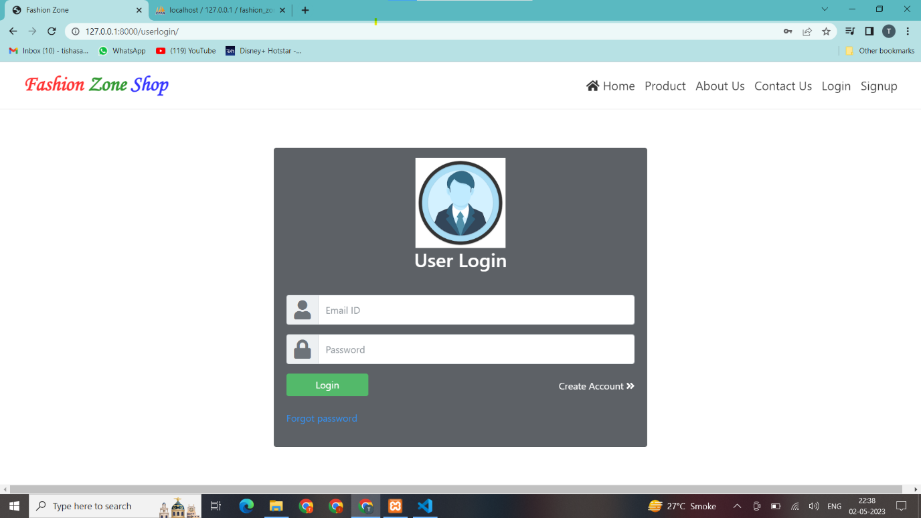

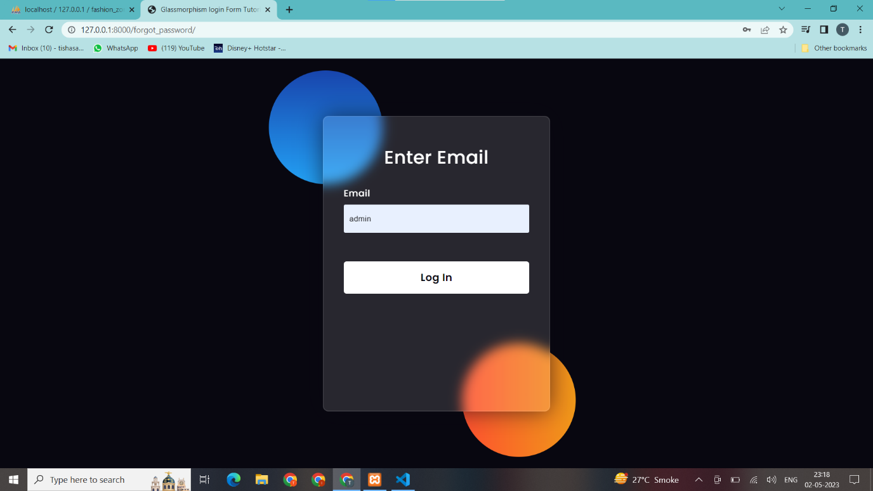

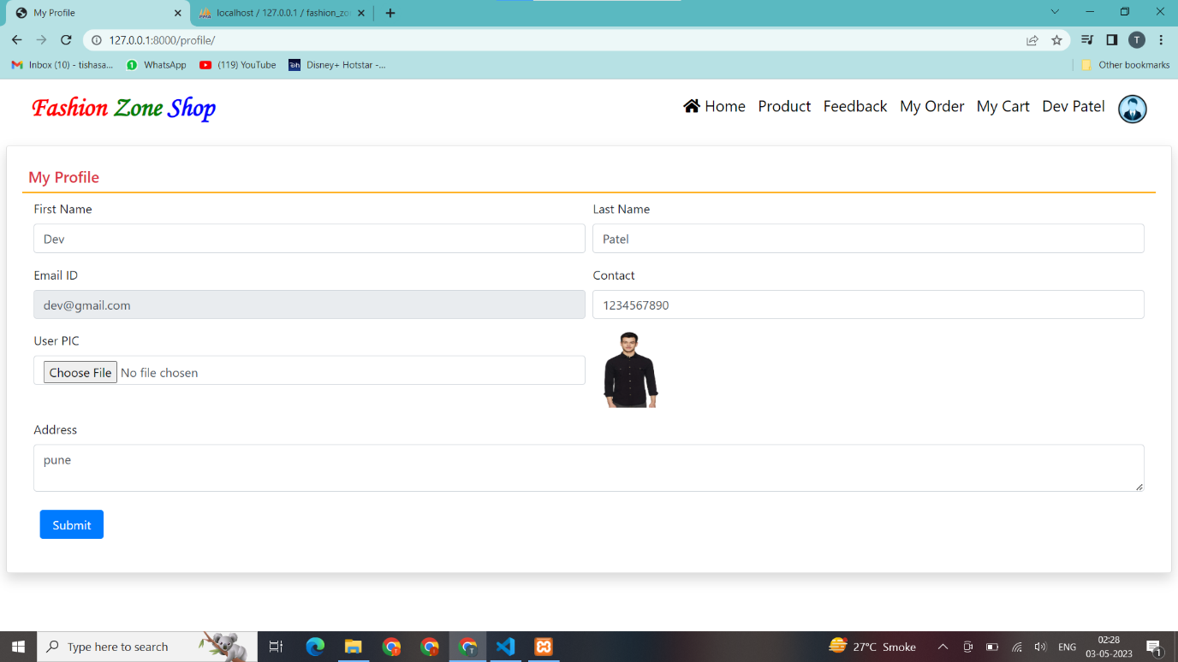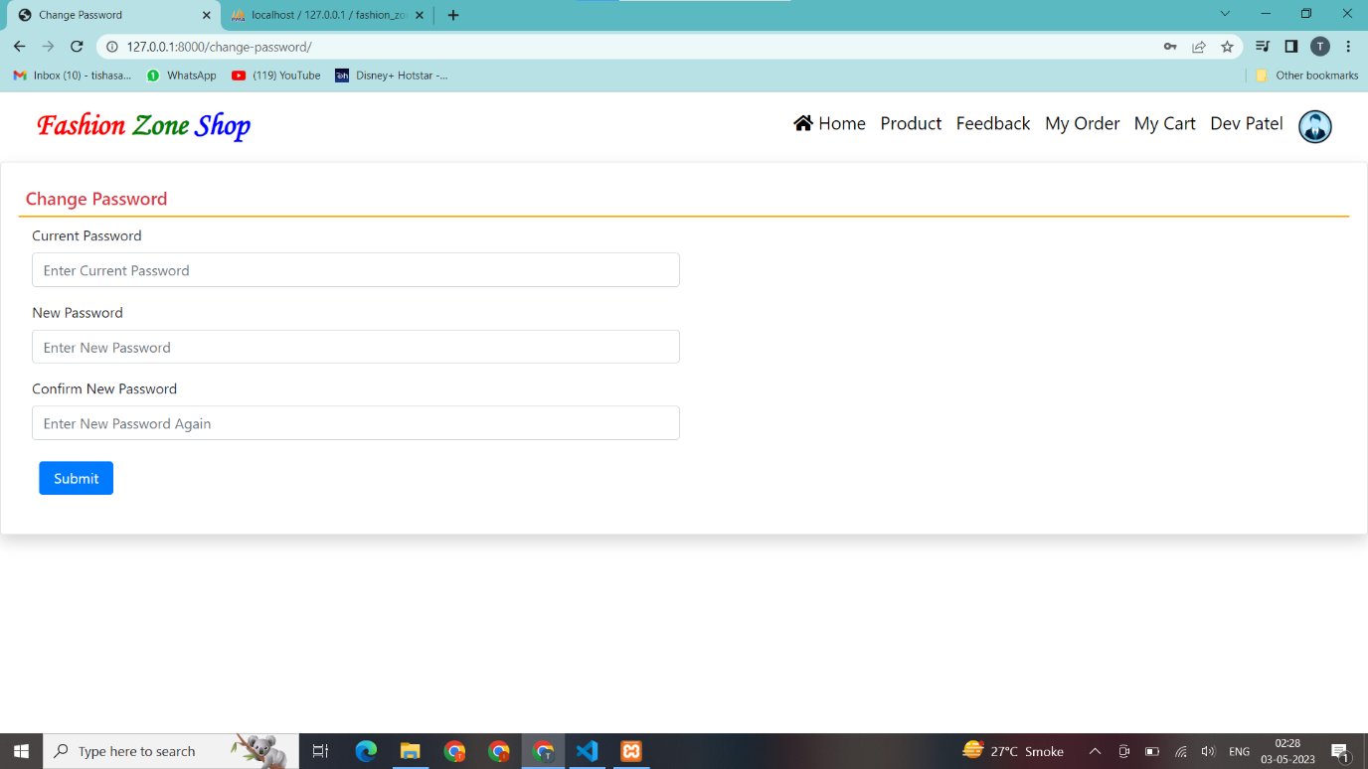

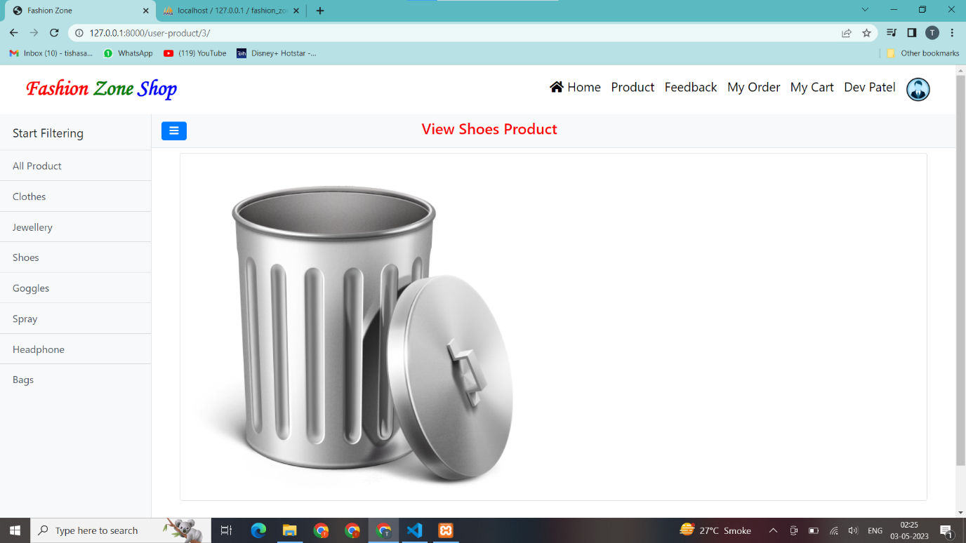

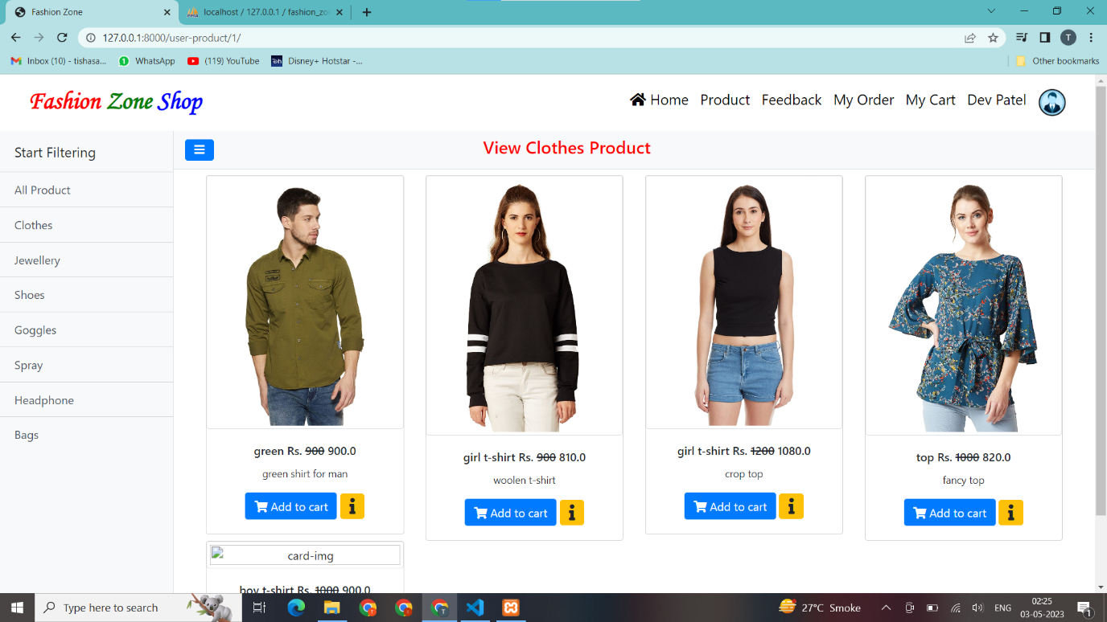

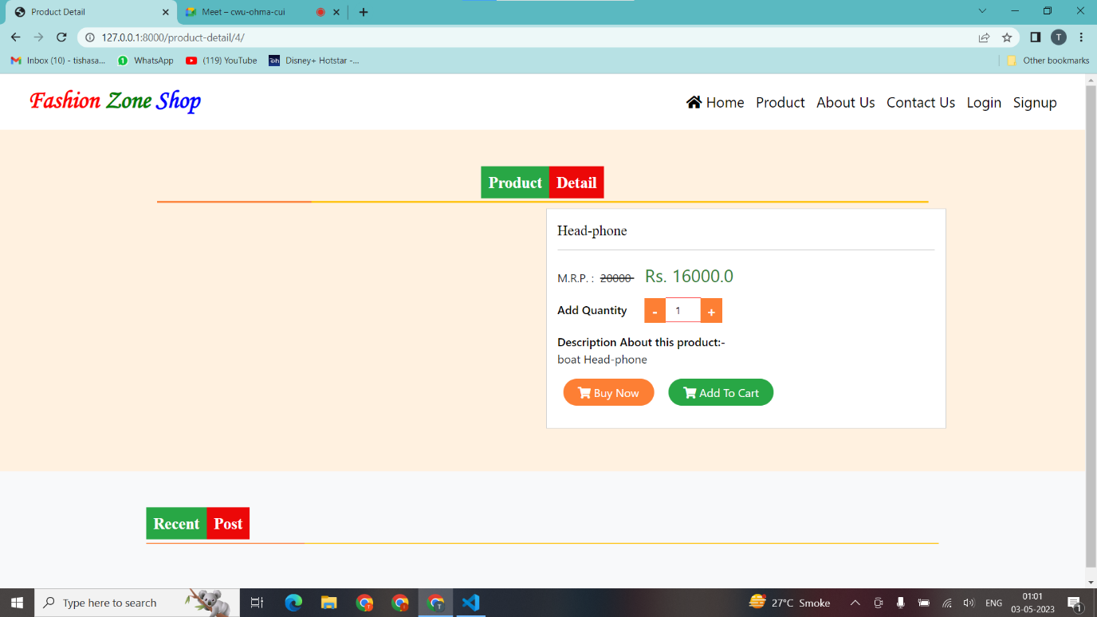

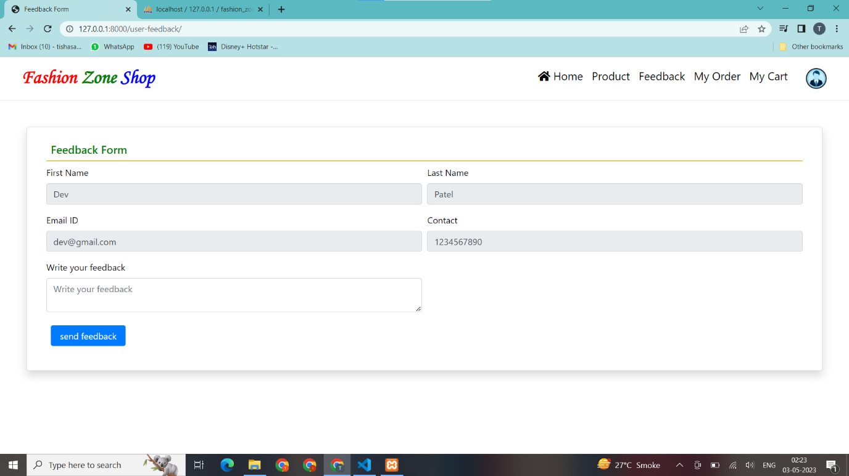

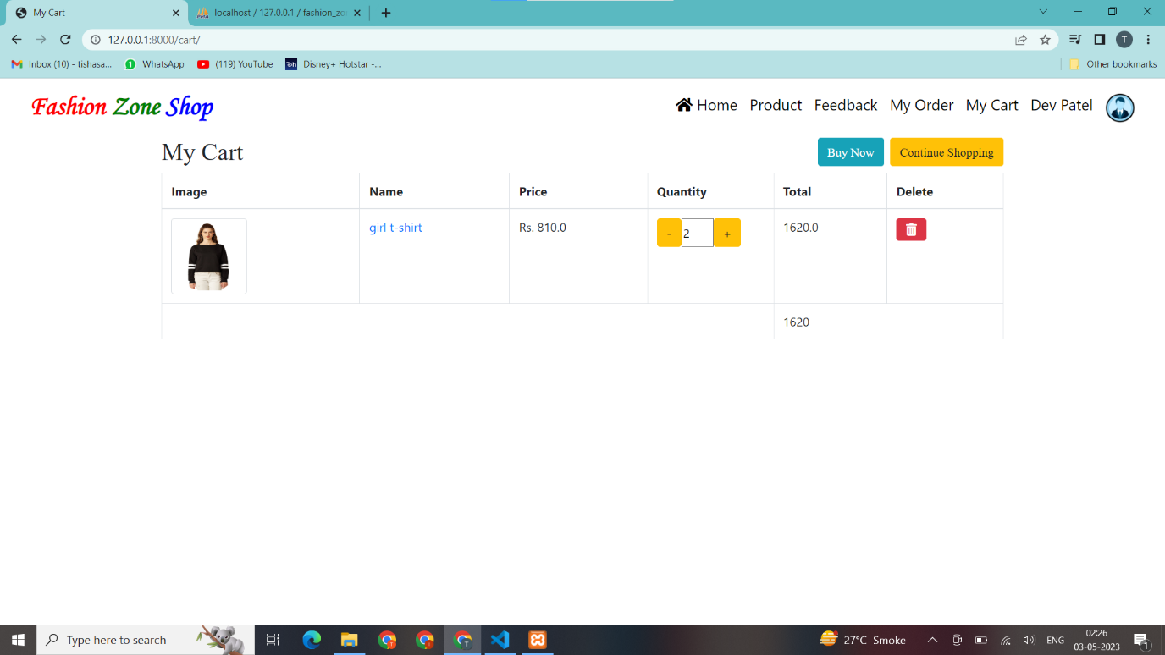

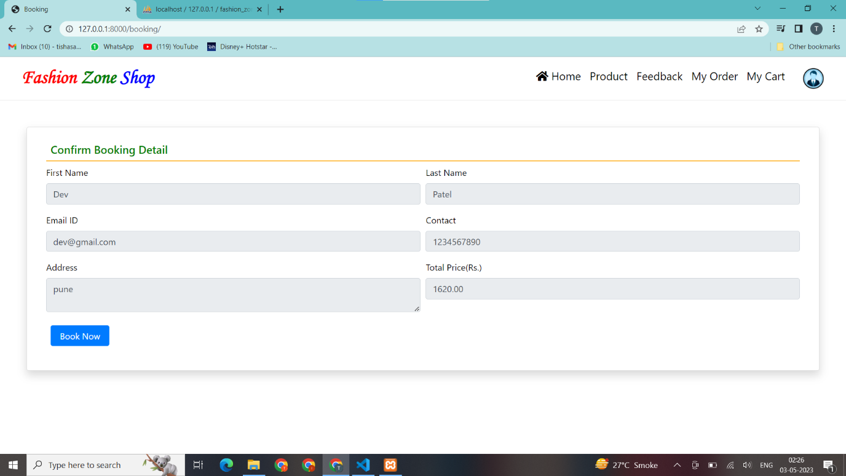

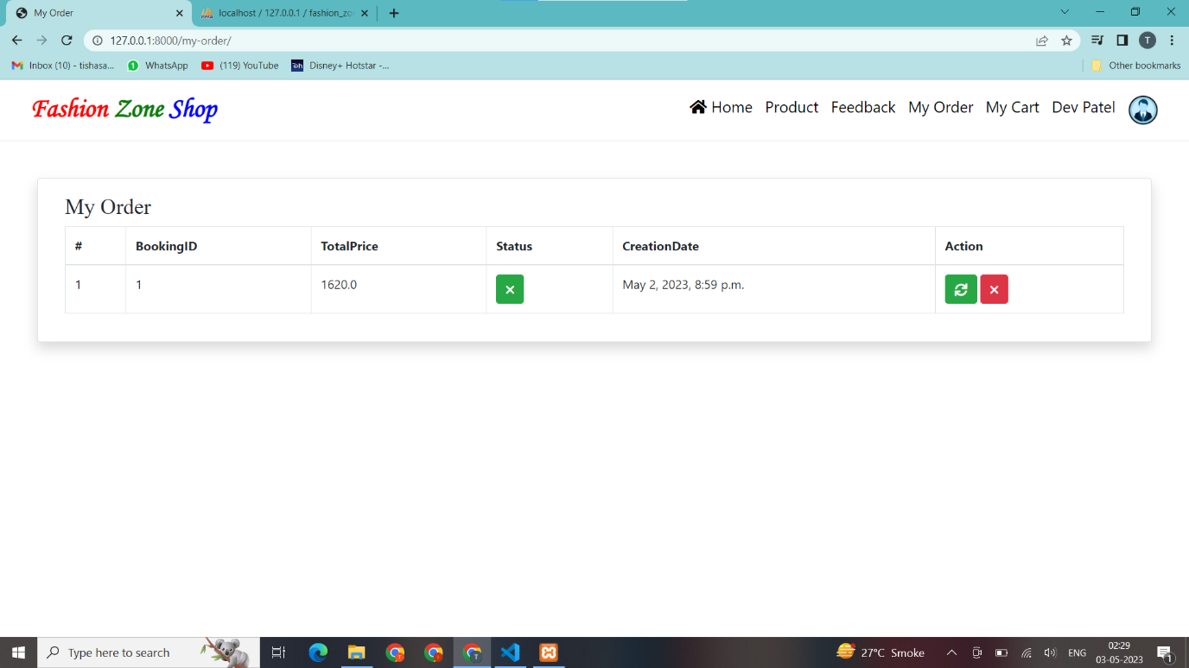

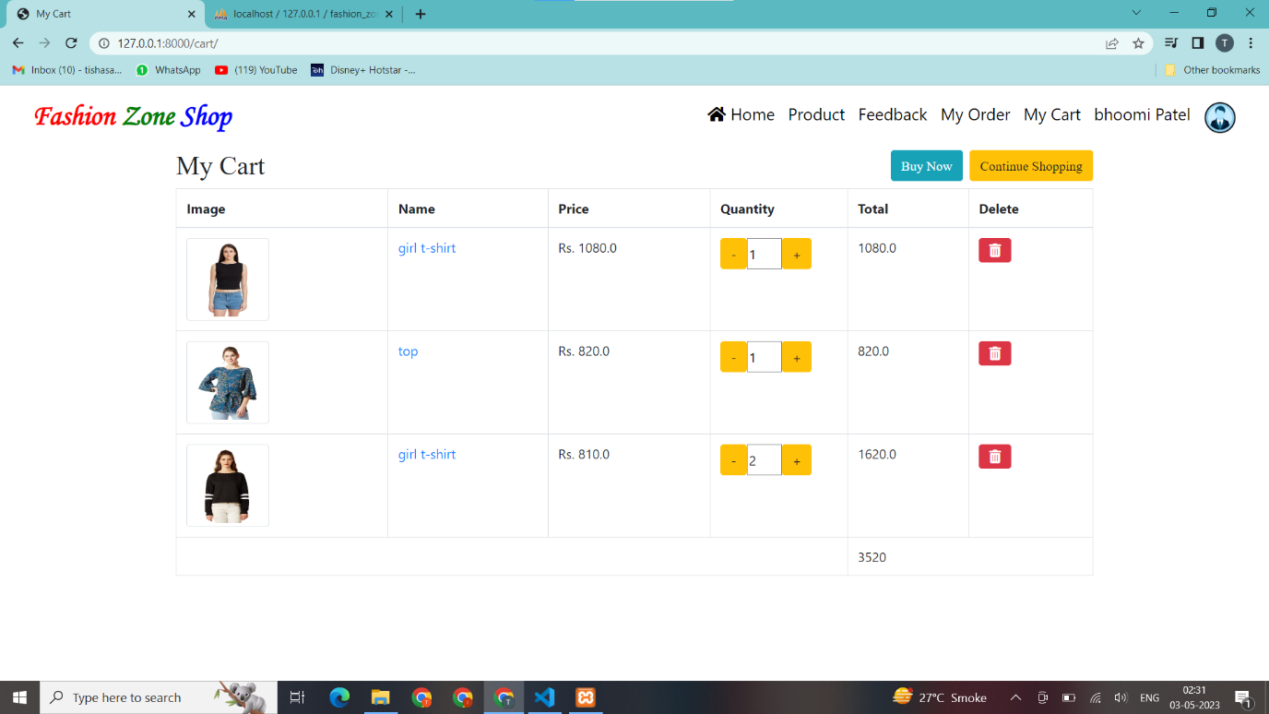

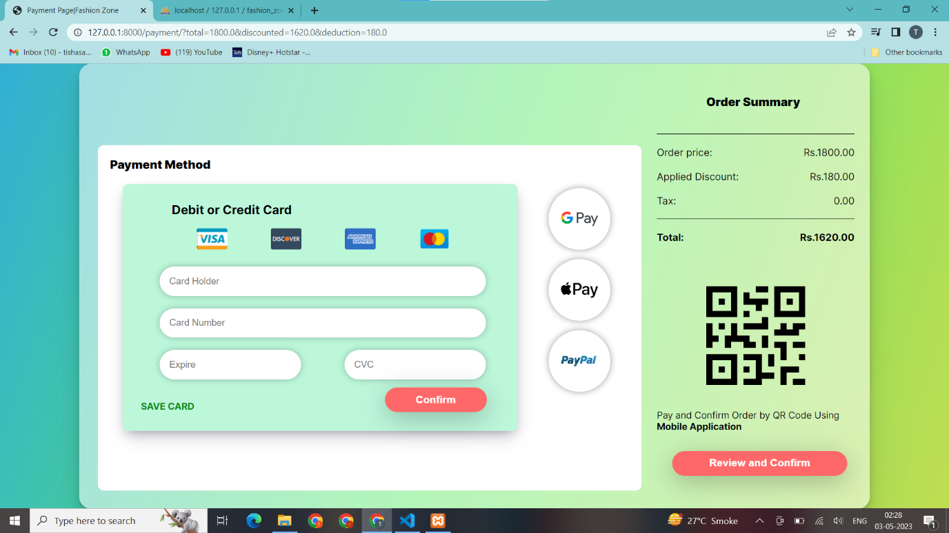

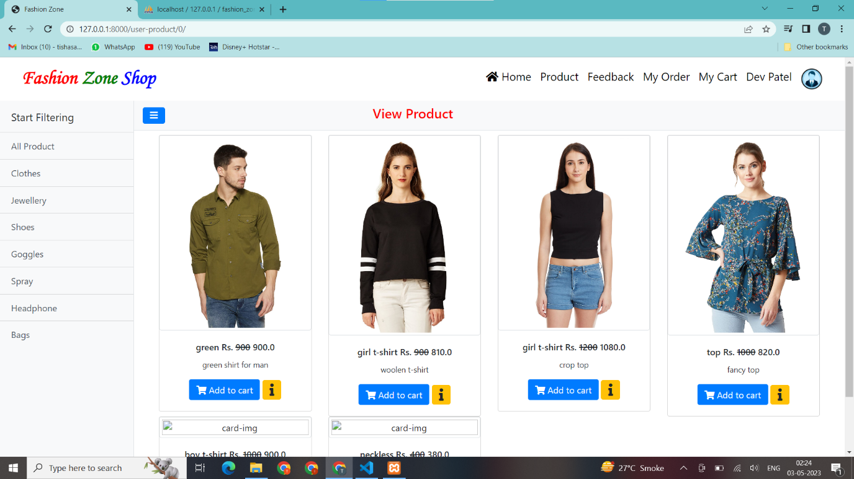

* + - **Seller**

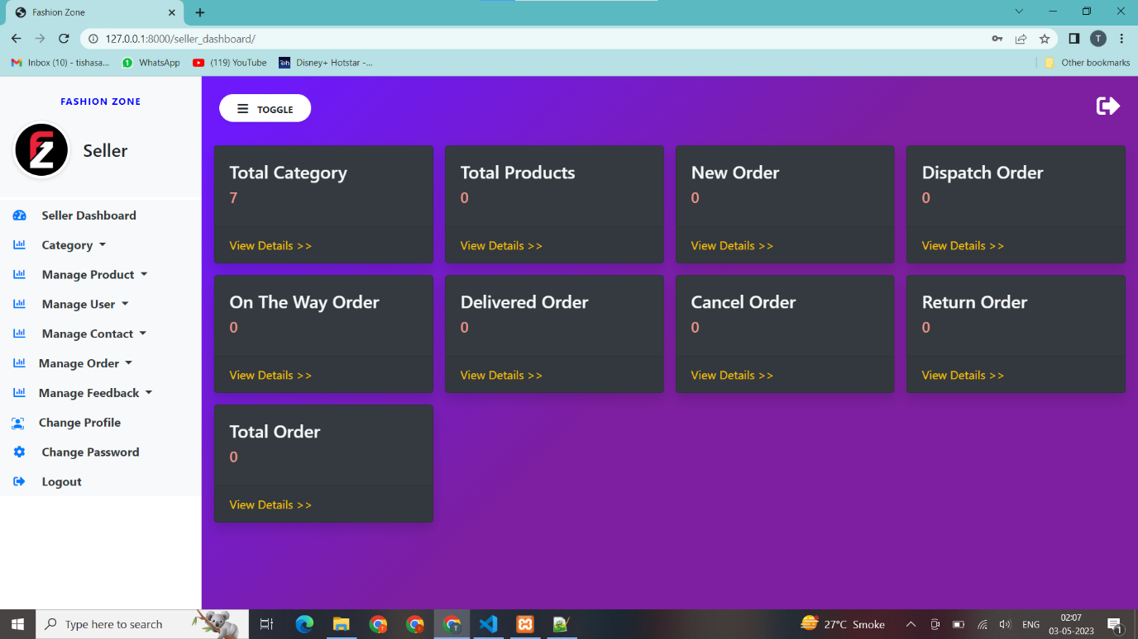

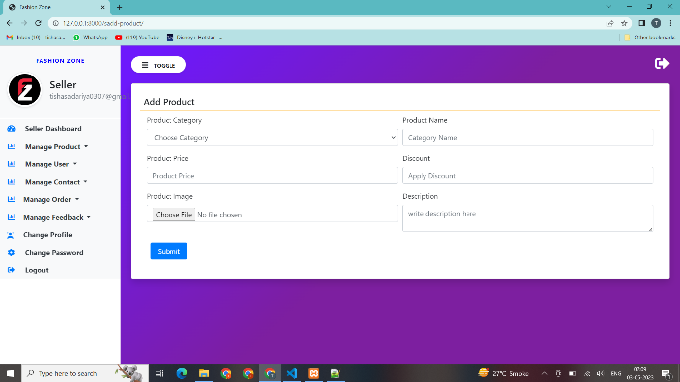

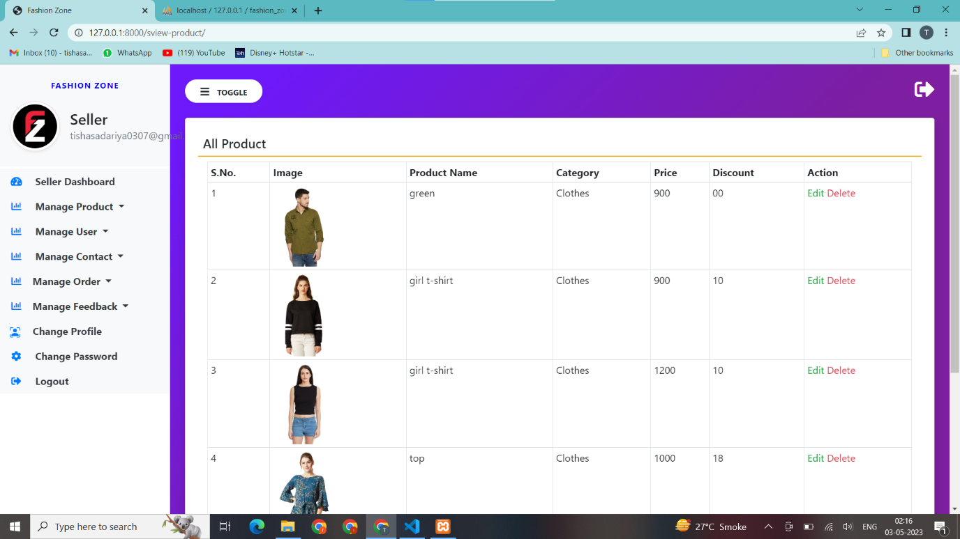

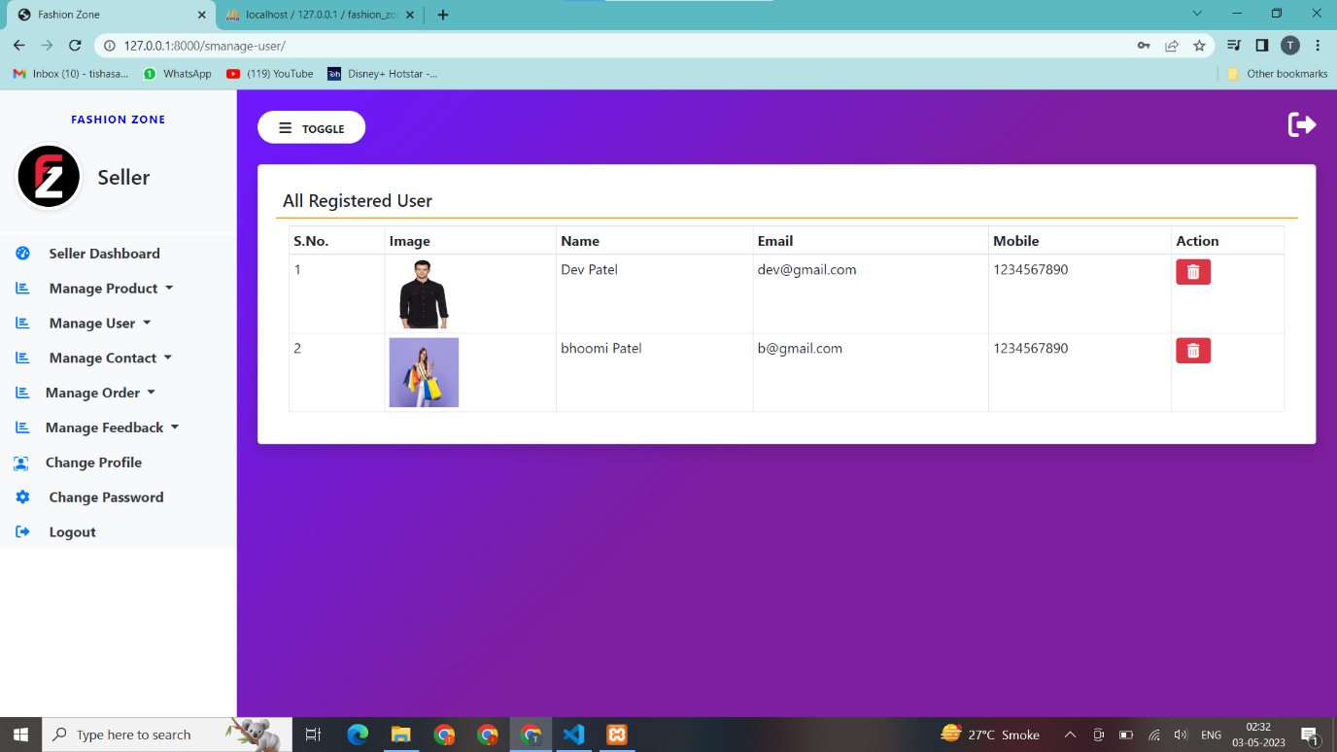

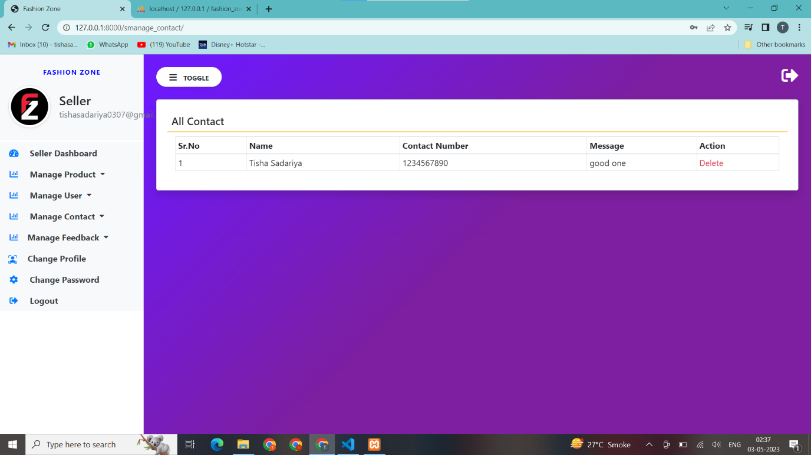

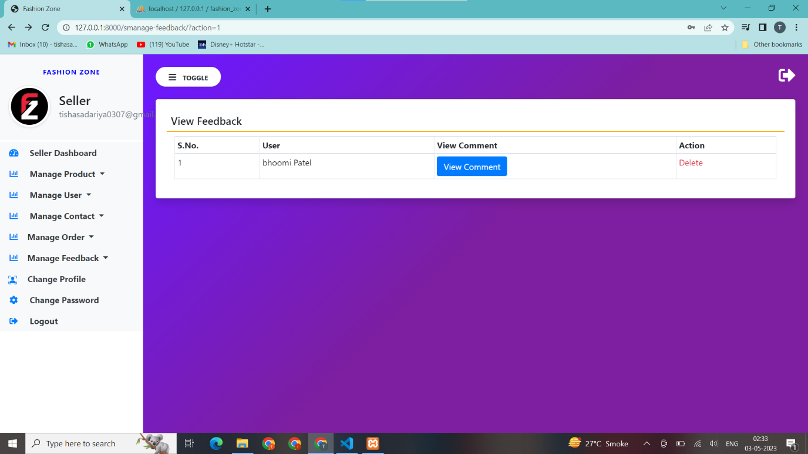

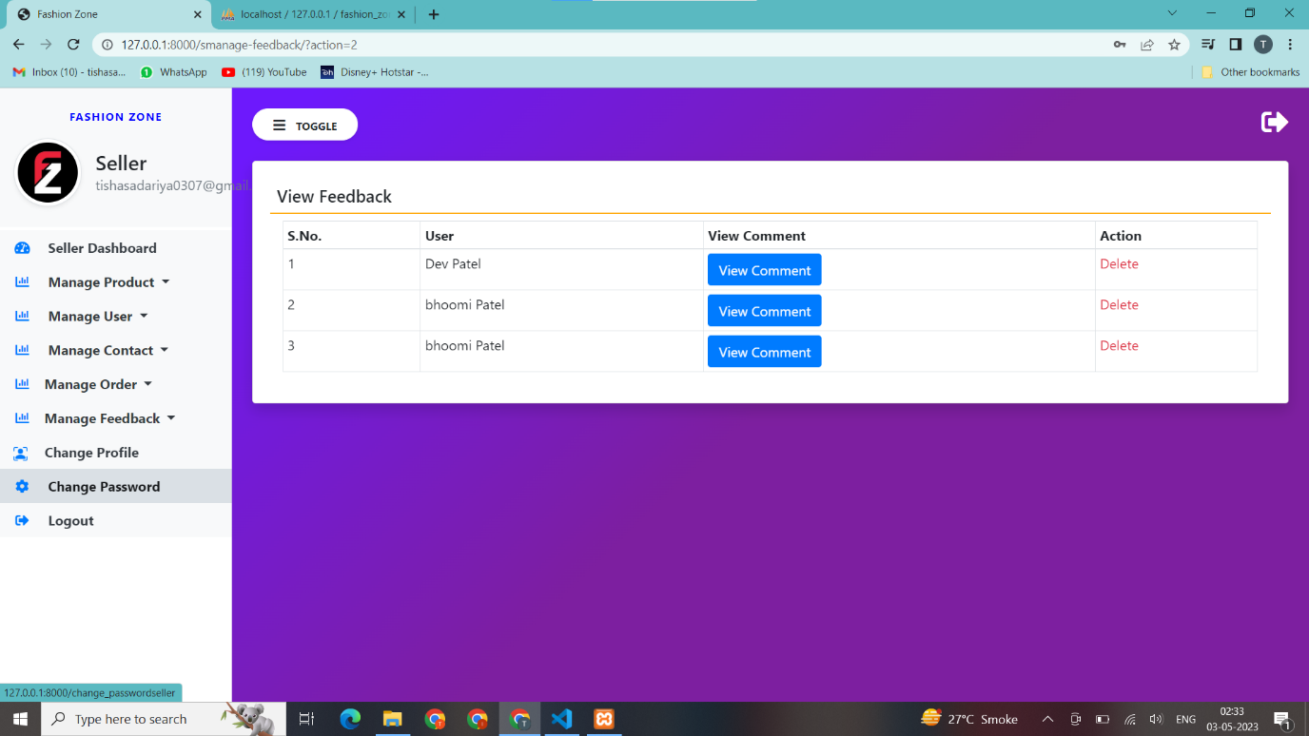

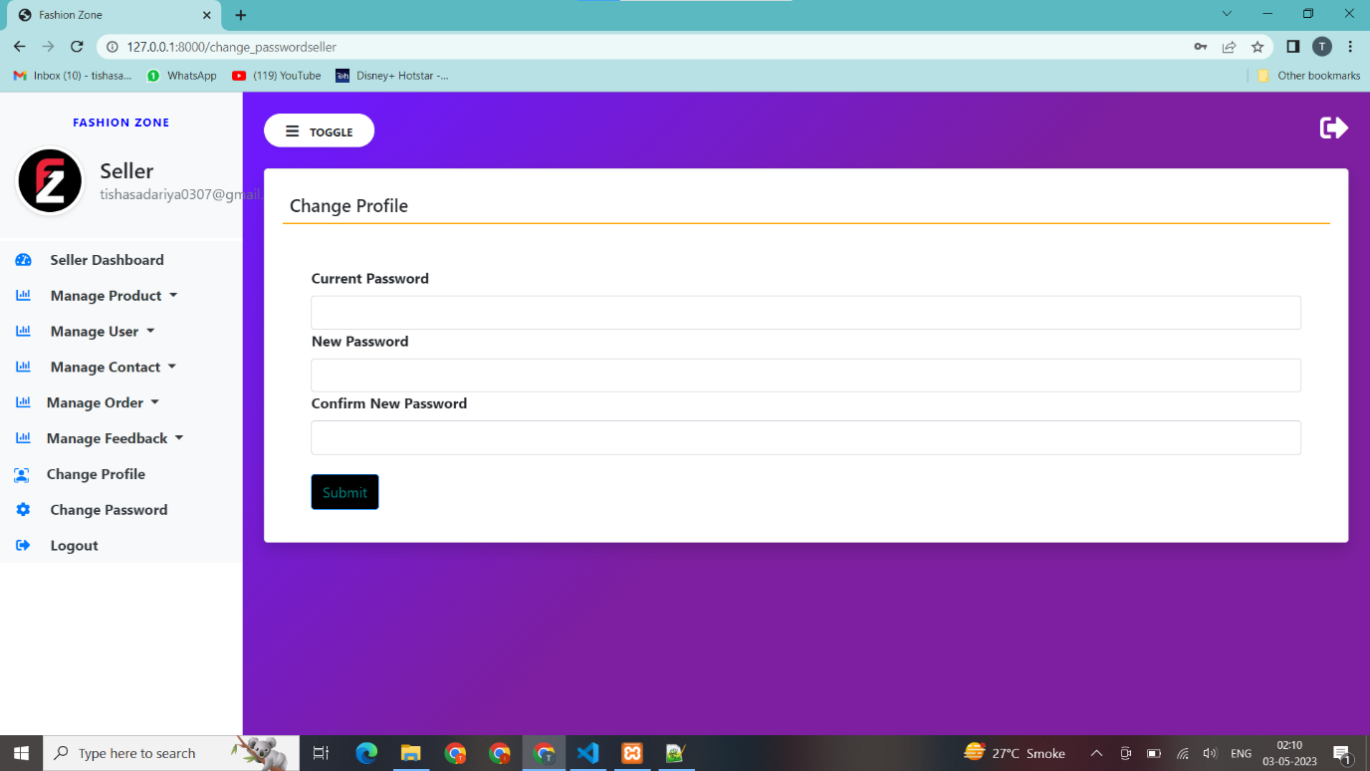

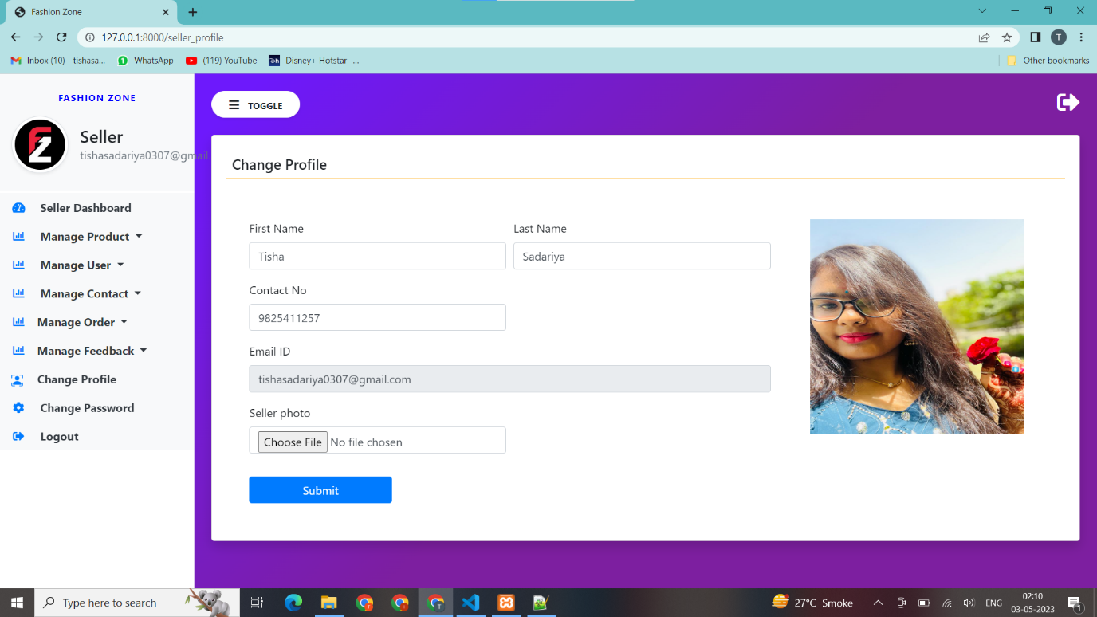

* + - **Admin**

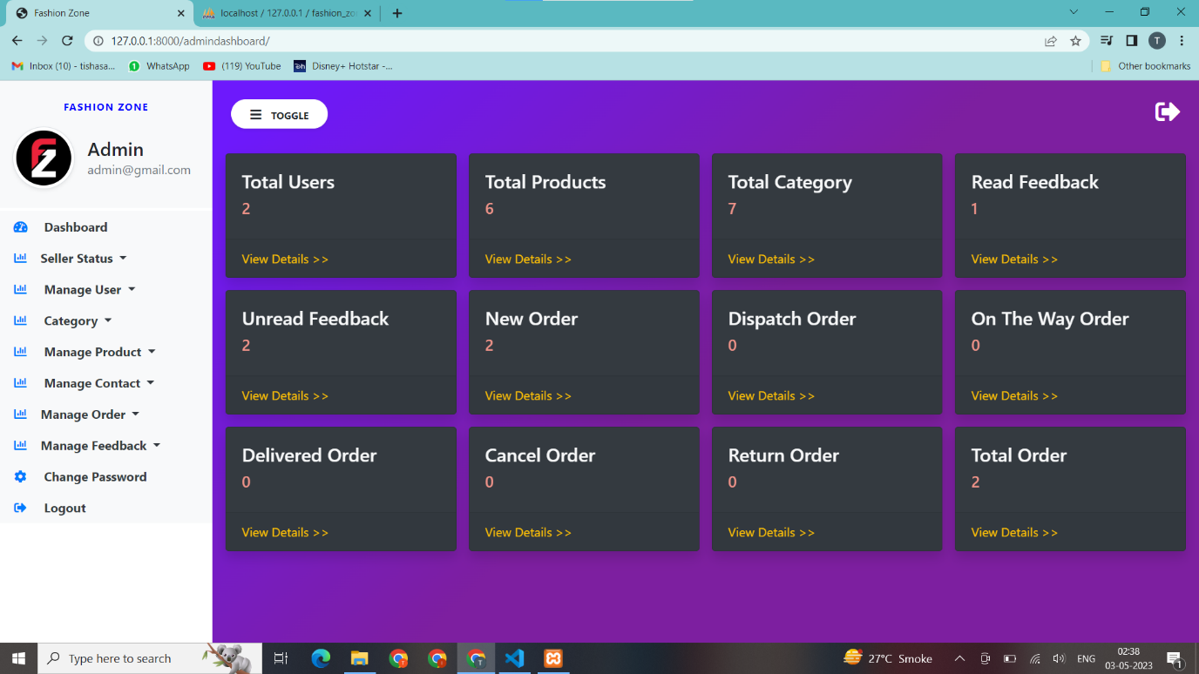

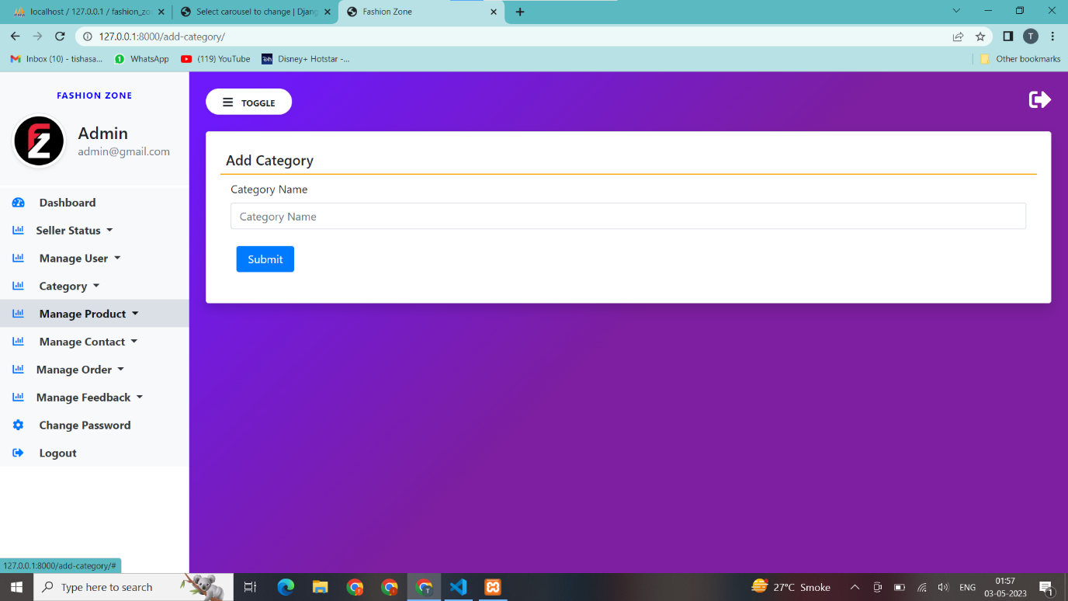

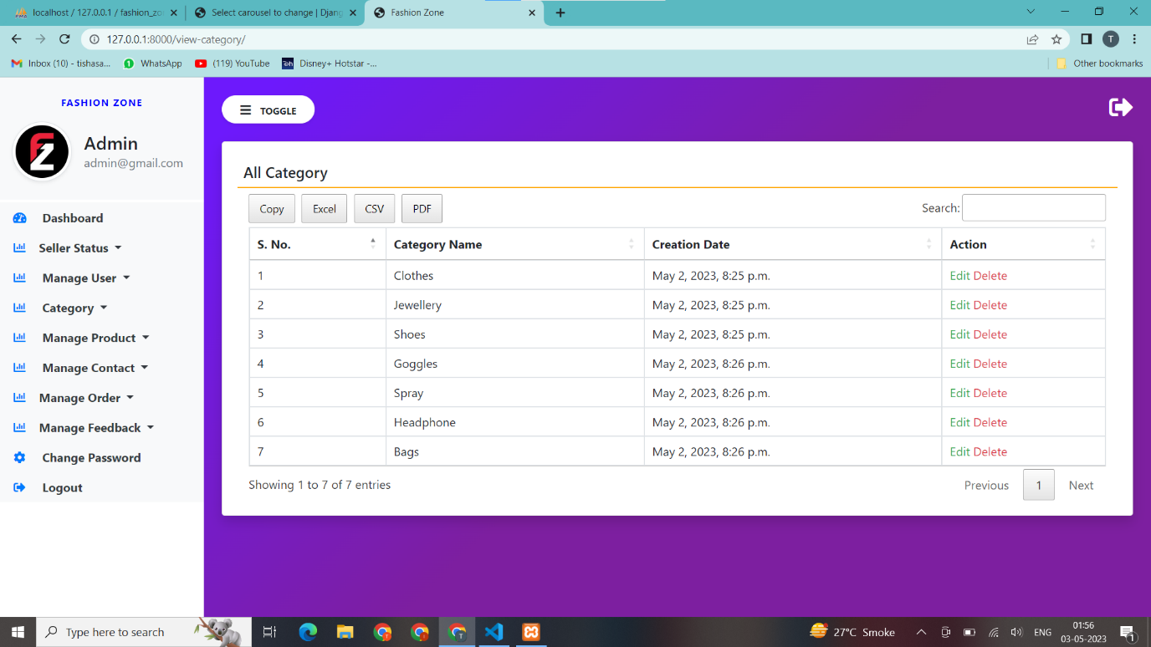

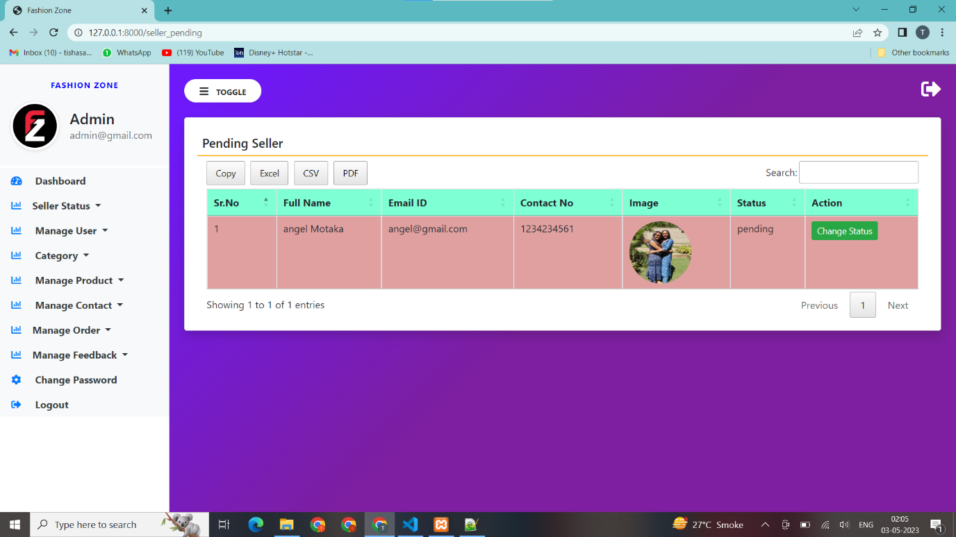

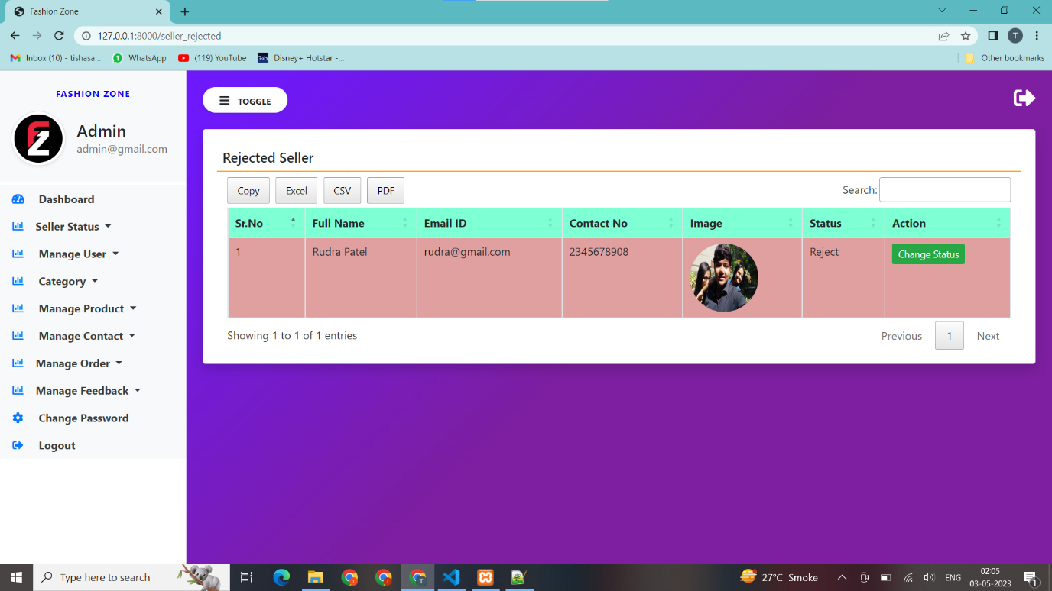

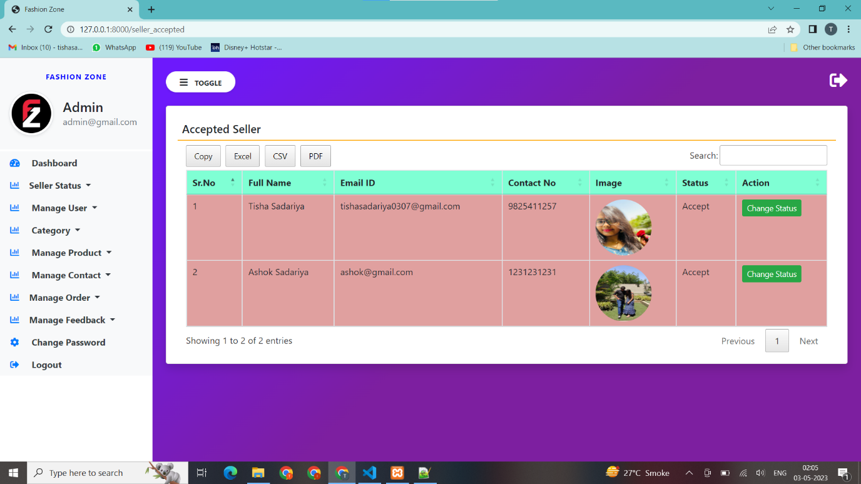

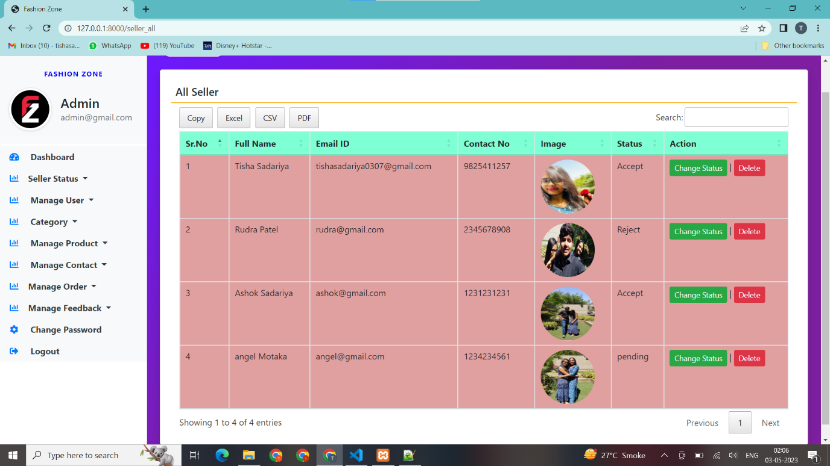

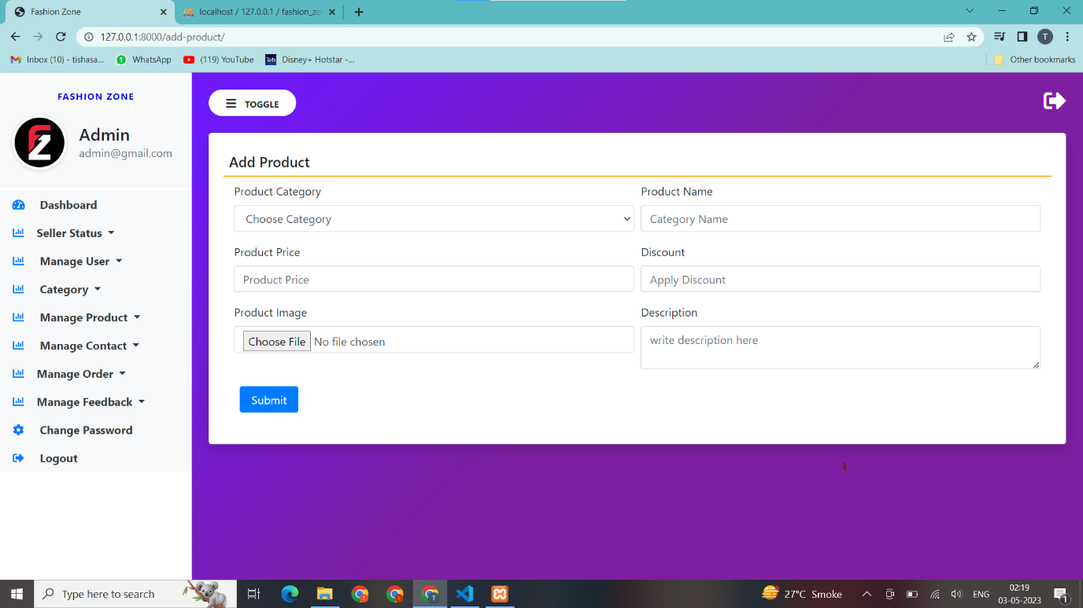

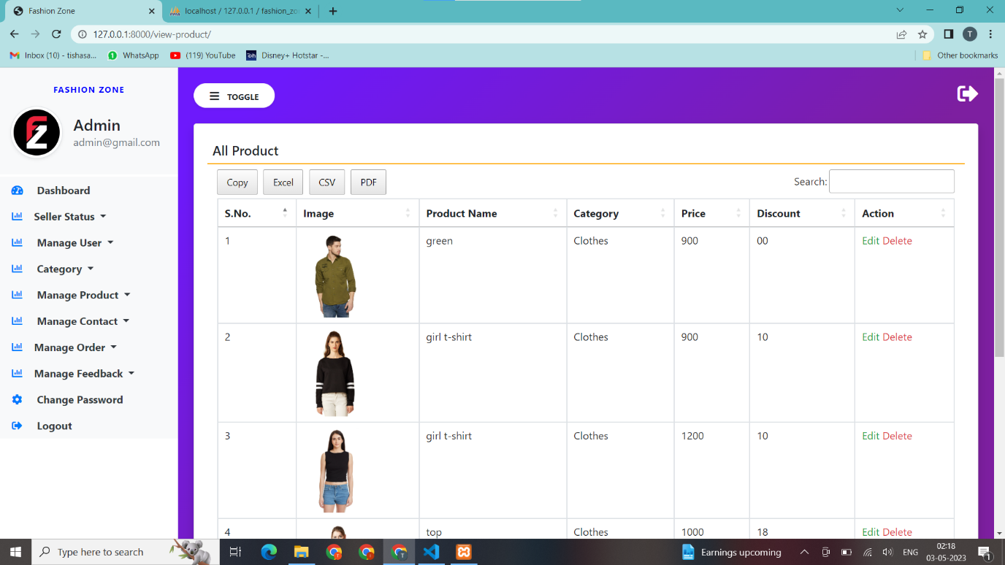

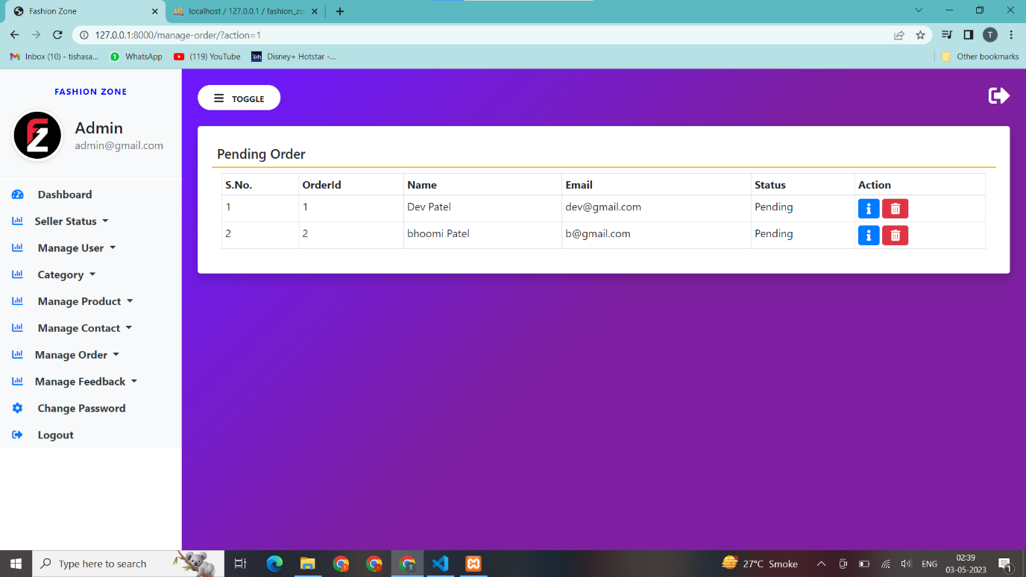

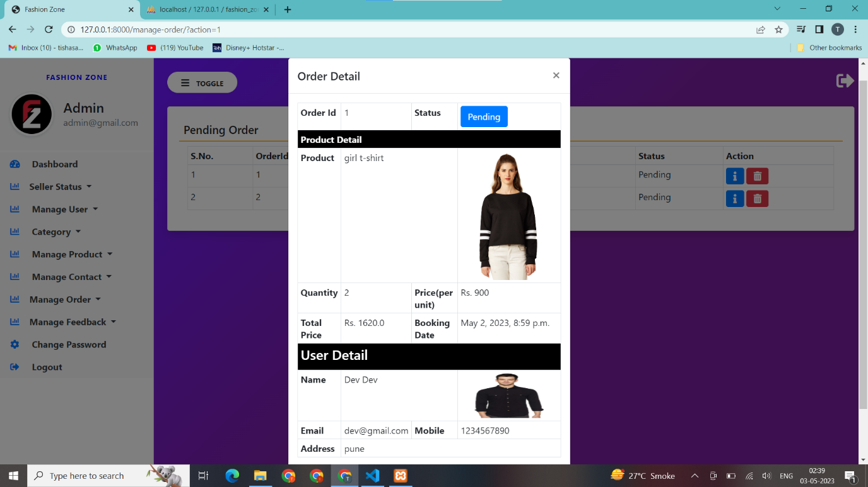

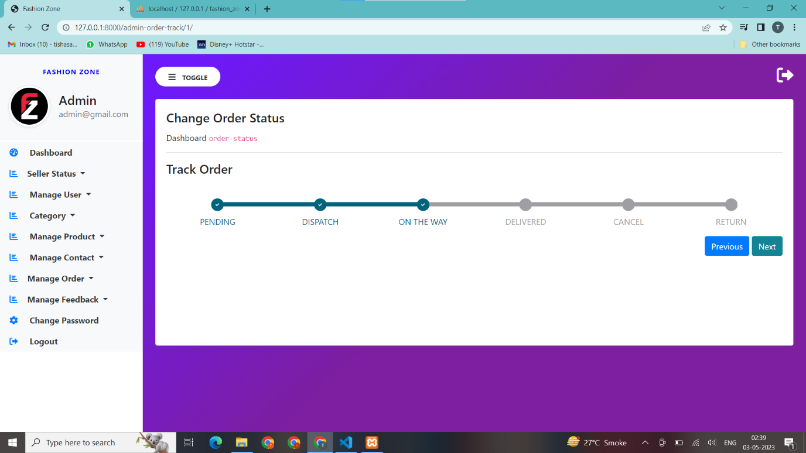

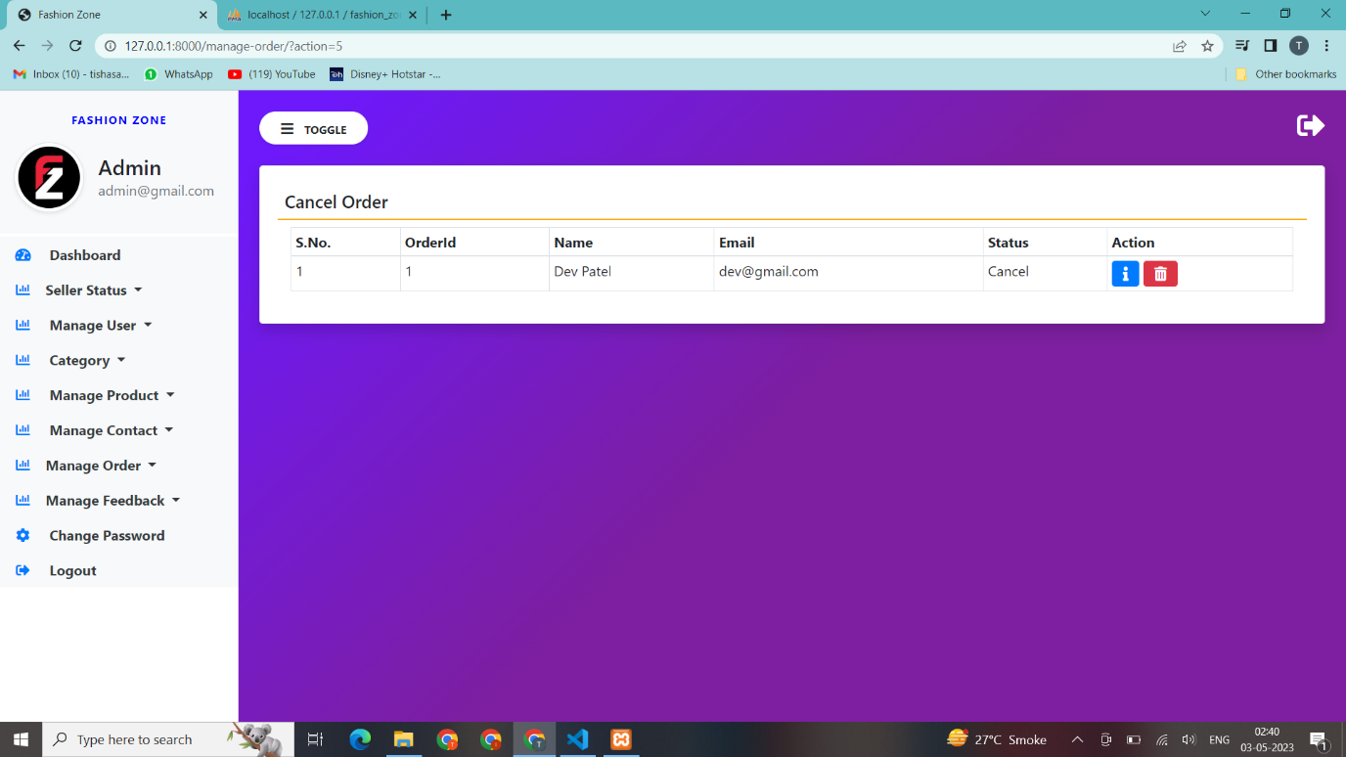

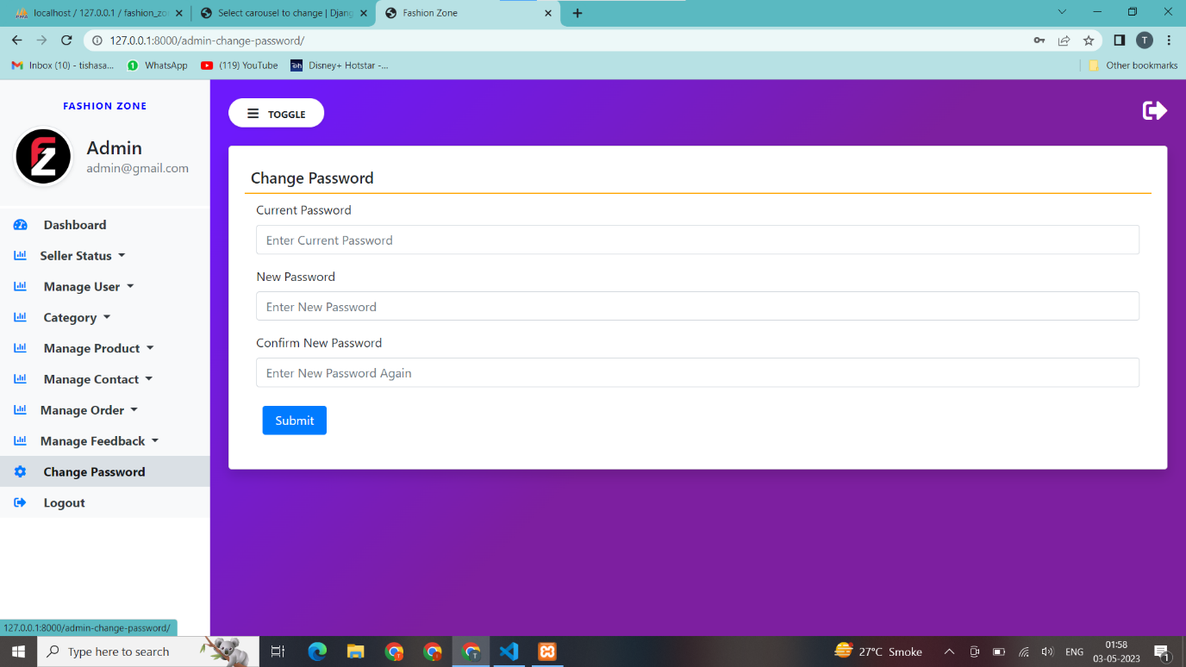

1. **Agile Document**
   1. **Agile Project Charter**

|  |  |
| --- | --- |
| General Project Information | |
| Project Name | Fashion Zone |
| Project Champion | Tisha Sadariya, Khushi Makwana, Dhruvil Barot |
| Project Sponsor | LJ Institute Of Computer Application |
| Project Manager | Prof. Jignesh Doshi, Prof. Anuradha Acharya |
| Expected Start Date | 17-Mar-2023 |
| Expected Completion Date | 04-May-2023 |

|  |  |
| --- | --- |
| Project Details | |
| Mission | The main aim to develop of the Project on Fashion Zone is to provide suitable outfits like clothes, jewellery, shoes, makeup items, goggles and spray to Operator. It manages all the information about Operator and Brand Provider. It's managing the status of Brand Provider. |
| Vision | Making the existing system fully automatic which will save lots of human resources work. Avoid data manipulations, Data inconsistency & redundancy. |
| Scope | The Scope for the system is to maintain Operator and Band Provider records. It’s Provide Customized Outfits. It’s Less Data Redundancy. Any (Authorized, Guest) user can use this system. |

* 1. **Agile Road map/ Schedule**

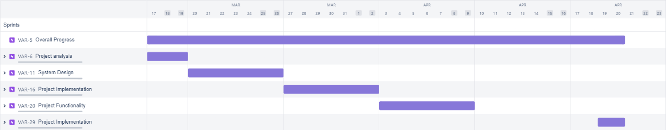

**------------------------------------------------------------------------------------------------**

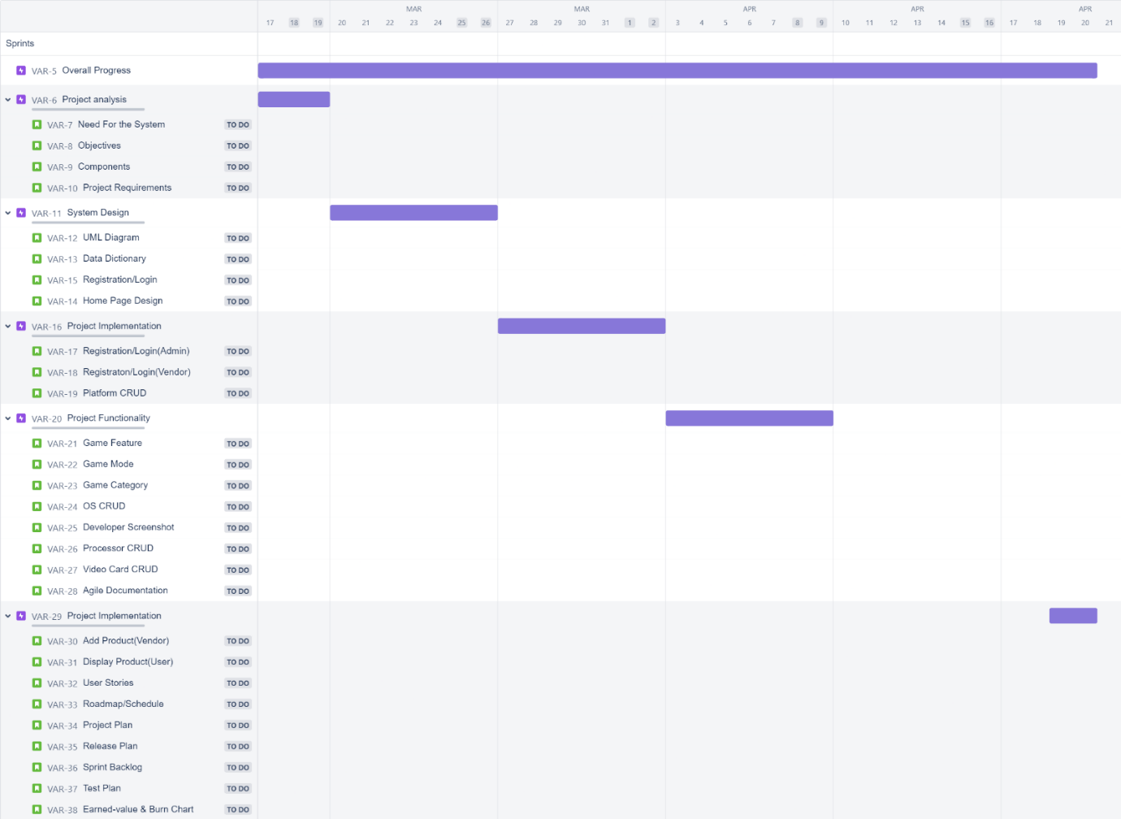

* 1. **Agile Project Plane**

|  |  |  |  |  |
| --- | --- | --- | --- | --- |
| Task Name | Durations | Start Date | Finish Date | Status |
| Basic Project Structure | 3d | 17-03-23 | 20-03-23 | Complete |
| Database Management | 2d | 22-03-23 | 24-03-23 | Complete |
| Login all Users(Admin, Seller, User) | 4d | 24-03-23 | 28-03-23 | Complete |
| Manage Users | 1d | 29-03-23 | 29-03-23 | Complete |
| Manage Seller | 2d | 30-03-23 | 31-04-23 | Complete |
| Category CRAD (Admin, User) | 3d | 01-04-23 | 03-04-23 | Complete |
| Carousel CRAD (Admin, User) | 2d | 04-04-23 | 05-04-23 | Complete |
| Product CRAD (Admin, Seller, User, Visitors) | 6d | 06-04-23 | 11-04-23 | Complete |
| Manage Contact Us | 2d | 12-04-23 | 13-04-23 | Complete |
| Manage Feedback | 2d | 14-04-23 | 15-04-23 | Complete |
| Change Password | 2d | 16-04-23 | 17-04-23 | Complete |
| Forget Password | 2d | 18-04-23 | 19-04-23 | Complete |
| Change Profile | 2d | 20-04-23 | 21-04-23 | Complete |
| Manage Order | 7d | 22-04-23 | 28-04-23 | Complete |
| Dashboard | 2d | 29-04-23 | 30-04-23 | Complete |
| About us | 1d | 01-05-23 | 01-05-23 | Complete |
| Contact us | 1d | 02-05-23 | 02-05-23 | Complete |

* 1. **Agile User Story**

|  |  |  |  |
| --- | --- | --- | --- |
| User Story ID | As a  <type of user> | I want to  <perform some task> | so that I can <achieve some goal> |
| 1 | Admin | Login and Logout | Manage system and services for user’s satisfaction |
| 2 | Admin | Manage Company | Know details of company/seller added |
| 3 | Admin | Manage  product (Sale) | Know details of product added for purchase |
| 4 | Admin | Manage product  (Services) | Know details of product added for service |
| 5 | Admin | View Order | View Customer details and order |
| 6 | Admin | Manage Offers | Know the details of offer added |
| 7 | Admin | Search/Filter  product | Know the details of product in a sec |
| 8 | Customer | Login and Logout | Have a unique profile to manage |
| 9 | Customer | View product Sales | Purchase product from the system |
| 10 | Customer | Search/Filter  product | Know the details of product in a sec |
| 11 | Customer | Manage Address | Update address if I shift my place |
| 12 | Customer | Manage Cart | View my items added in cart and remove if not needed |
| 13 | Customer | Place Order | Place my final order |
| 14 | Customer | View Offers | Know offers provided by the system |

* 1. **Agile Release Plan**

|  |  |  |  |  |  |
| --- | --- | --- | --- | --- | --- |
| TASK NAME | DURATION | START | FINISH | STATUS | RELEASE DATE |
| Admin Side/Seller Side/Customer Side:  -Login/Registration  -Logout | 3 days | 17/03/2023 | 19/03/2023 | complete | 20/03/2023 |
| Admin Side:  - Carousel CRUD  - Category CRUD  - Product CRUD  - Seller CRUD | 7 days | 20/03/2023 | 26/03/2023 | complete | 27/03/2023 |
| Admin Side:  - Contact-us CRUD  - Feedback CRUD  - booking CRUD  - cart CRUD | 7 days | 27/03/2023 | 02/04/2023 | complete | 03/04/2023 |
| Admin Side:  - Track order CRUD  Seller Side:  - Display CRUD | 7 days | 03/04/2023 | 09/04/2023 | complete | 10/04/2023 |
| Seller Side:  -Contact CRUD  Customer Side:  -Index Page  -Main Page  -Product Details | 7 days | 10/04/2023 | 16/04/2023 | complete | 17/04/2023 |
| Customer Side:  -Profile Page  -Contact Page  -Cart Module | 7 days | 19/04/2023 | 23/04/2023 | Complete | 24/04/2023 |
| Customer Side:  -Buy Order  Admin Side:  -Reports  Seller Side  -Reports | 7 days | 24/04/2023 | 30/04/2023 | Complete | 01/04/2023 |

* 1. **Agile Spring Backlog**

|  |  |  |  |  |  |
| --- | --- | --- | --- | --- | --- |
| Task Name | Story | Sprint Ready | Priority | Status | Story Points |
| Basic Project Structure | Yes | Yes | High | Complete | 10 |
| Designing | Yes | Yes | High | Complete | 10 |
| Database Management | Yes | Yes | High | Complete | 10 |
| User Management | Yes | Yes | High | Complete | 10 |
| Login | Yes | Yes | High | Complete | 10 |
| Registration | Yes | Yes | High | Complete | 10 |
| Manage Services | Yes | Yes | High | Complete | 10 |
| Add Services | Yes | Yes | High | Complete | 10 |
| Available Services | Yes | Yes | High | Complete | 10 |
| View Services | Yes | Yes | High | Complete | 10 |
| Update Services | Yes | Yes | High | Complete | 10 |
| Delete Services | Yes | Yes | High | Complete | 10 |
| Manage products | Yes | Yes | High | Complete | 10 |
| Add products | Yes | Yes | High | Complete | 10 |
| Update products | Yes | Yes | High | Complete | 10 |
| Delete products | Yes | Yes | High | Complete | 10 |
| Manage Saleable products | Yes | Yes | High | Complete | 10 |
| Add Saleable products | Yes | Yes | High | Complete | 10 |
| View Saleable products | Yes | Yes | High | Complete | 10 |
| Update Saleable products | Yes | Yes | High | Complete | 10 |
| Delete Saleable products | Yes | Yes | High | Complete | 10 |
| Search products | Yes | Yes | Medium | Complete | 08 |
| Apply Filter | Yes | Yes | Medium | Complete | 08 |
| Manage Service Cart | Yes | Yes | High | Complete | 10 |
| Add Service Cart | Yes | Yes | High | Complete | 10 |
| View Service Cart | Yes | Yes | High | Complete | 10 |
| Delete Service Cart | Yes | Yes | High | Complete | 10 |
| Manage Company | Yes | Yes | High | Complete | 10 |
| Add Company | Yes | Yes | High | Complete | 10 |
| View Company | Yes | Yes | High | Complete | 10 |
| Update Company | Yes | Yes | High | Complete | 10 |
| Delete Company | Yes | Yes | High | Complete | 10 |
| Manage Store | Yes | Yes | Medium | Complete | 08 |
| Add Store | Yes | Yes | Medium | Complete | 08 |
| View Store | Yes | Yes | Medium | Complete | 08 |
| Update Store | Yes | Yes | Medium | Complete | 08 |
| Manage Orders | Yes | Yes | High | Complete | 10 |
| Accept Order | Yes | Yes | High | Complete | 10 |
| View Order | Yes | Yes | High | Complete | 10 |
| Cancel Order | Yes | Yes | High | Complete | 10 |
| Manage Cart | Yes | Yes | High | Complete | 10 |
| Add to Cart | Yes | Yes | High | Complete | 10 |
| View Cart | Yes | Yes | High | Complete | 10 |
| Delete Cart | Yes | Yes | High | Complete | 10 |
| Manage Profile | Yes | Yes | High | Complete | 10 |
| Change Password | Yes | Yes | High | Complete | 10 |
| Change Email | Yes | Yes | Medium | Complete | 08 |
| Manage Address Book | Yes | Yes | High | Complete | 10 |
| Add Address | Yes | Yes | High | Complete | 10 |
| View Address | Yes | Yes | High | Complete | 10 |
| Update Address | Yes | Yes | High | Complete | 10 |
| Delete Address | Yes | Yes | High | Complete | 10 |
| Manage Offers | Yes | Yes | Medium | Complete | 08 |
| Add Offer | Yes | Yes | Medium | Complete | 08 |
| View Offer | Yes | Yes | Medium | Complete | 08 |
| Delete Offer | Yes | Yes | Medium | Complete | 08 |

* 1. **Agile Test Plane**

|  |  |  |  |  |  |  |  |  |
| --- | --- | --- | --- | --- | --- | --- | --- | --- |
| **Project Name** | | **Fashion Zone** | | | **Device** | | Laptop | |
| **Test Case Id** | | 1 | | | **Test Title** | | Login, Manage Company | |
| **Module Name** | | Login, Manage company | | | **Tested By** | | Tisha | |
| **Priority** | | High | | | **Execution Date** | |  | |
| **Test** | **Test Step** | | **Action** | **Expected Result** | | **Actual Result** | | **Pass** |
| 1 | Open login page | | Open  Login  Page | Open Login Page | | Login Page Opened | | Yes |
| 2 | Enter Id and  Password of admin | | Enter Data | Validate User | | Admin data Validated | | Yes |
| 3 | Do login | | Click on login button | User should logged in | | Login successful | | Yes |
| 4 | After successful login, navigate to  Manage Company | | Open Company  page | Open  Company  Page | | Company Page Opened, added the data and displayed on user site | | Yes |

|  |  |  |  |  |  |  |  |  |
| --- | --- | --- | --- | --- | --- | --- | --- | --- |
| **Project Name** | | **Stark Solution** | |  | **Device** | | Laptop | |
| **Test Case Id** | | 2 | |  | **Test Title** | | Manage Cart and Order | |
| **Module Name** | | Manage Cart and Order (User) | |  | **Tested By** | | Tisha | |
| **Priority** | | High | |  | **Execution Date** | |  | |
| **Test** | **Test Step** | | **Action** | **Expected Result** | | **Actual Result** | | **Pass** |
| 1 | After you select your product from menu add it into your cart | | Open  Cart page | Open Cart Page | | Cart displayed with items selected | | No |
| 2 | After you select your items from menu add it into your cart | | Open  Cart page | Open Cart Page | | Cart displayed with items selected | | Yes |
| 3 | Delete item from cart | | In Cart Page | Cart page | | Item deleted from cart page | | Yes |
| 4 | Navigate to payment Page, enter address and  make Payment  online | | Open  Payment  Page | Open  Payment  Page | | Make Payment online | | Yes |
| 5 | After Payment, Place final order | | Open  Order  Page | Open Order Page | | Confirm final Order with particular date and Received mail of delivery | | Yes |

* 1. **Earned-value and Burn charts**

1. **Future Work**

As the world becomes increasingly digital, the future of e-commerce is limitless. Our website, Fashion Zone , will continue to adapt and evolve to meet the changing needs of our customers. We aim to expand our product offerings to include even more high-quality, affordable items for everyone. We will also strive to improve our user experience by enhancing our website's functionality and usability. Our focus on sustainability and thrift culture will continue to drive our efforts to make a positive impact on the environment and promote conscious consumerism. As we continue to grow, we look forward to serving our customers with the best online shopping experience possible.

1. **Bibliography**

* **Web Site Refranchise**
  + https://www.amazon.in/
  + https://www.flipkart.com/
  + https://www.w3schools.com/asp/webpages_intro.asp
  + [Releases · ColorlibHQ/AdminLTE (github.com)](https://github.com/ColorlibHQ/AdminLTE/releases)
  + <https://www.w3schools.com/bootstrap/bootstrap_ver.asp>
  + WWW.JAVATPOINT.COM
* **Book Refranchise**
  + Django Essentials
  + Samuel Dauzon